Adding the Zoom Meetings in Your Canvas Course

Go to your Canvas course and click Settings at the bottom of your menu.
Go to the third tab, Navigation

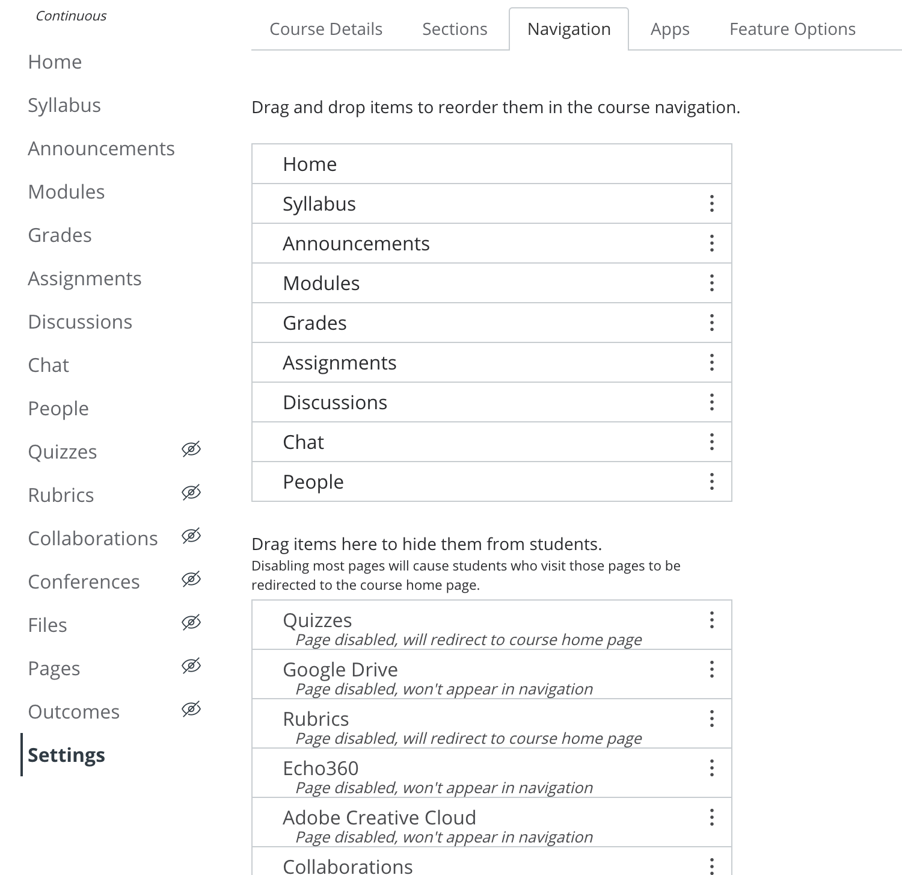

Items that appear in the top list will show in your course navigation and will be visible to your students. Items that appear in the bottom list will either be disabled and not appear in the navigation or appear in the navigation, but not be visible to students.

If you wish to use Zoom in your Canvas course, find Zoom – HIPAA in the bottom list and drag and drop it in the first list. Press the Save button.
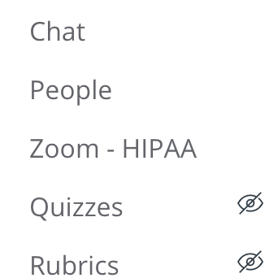

Click on the new menu item and you will see the following screen requesting access to your VCU Zoom account:

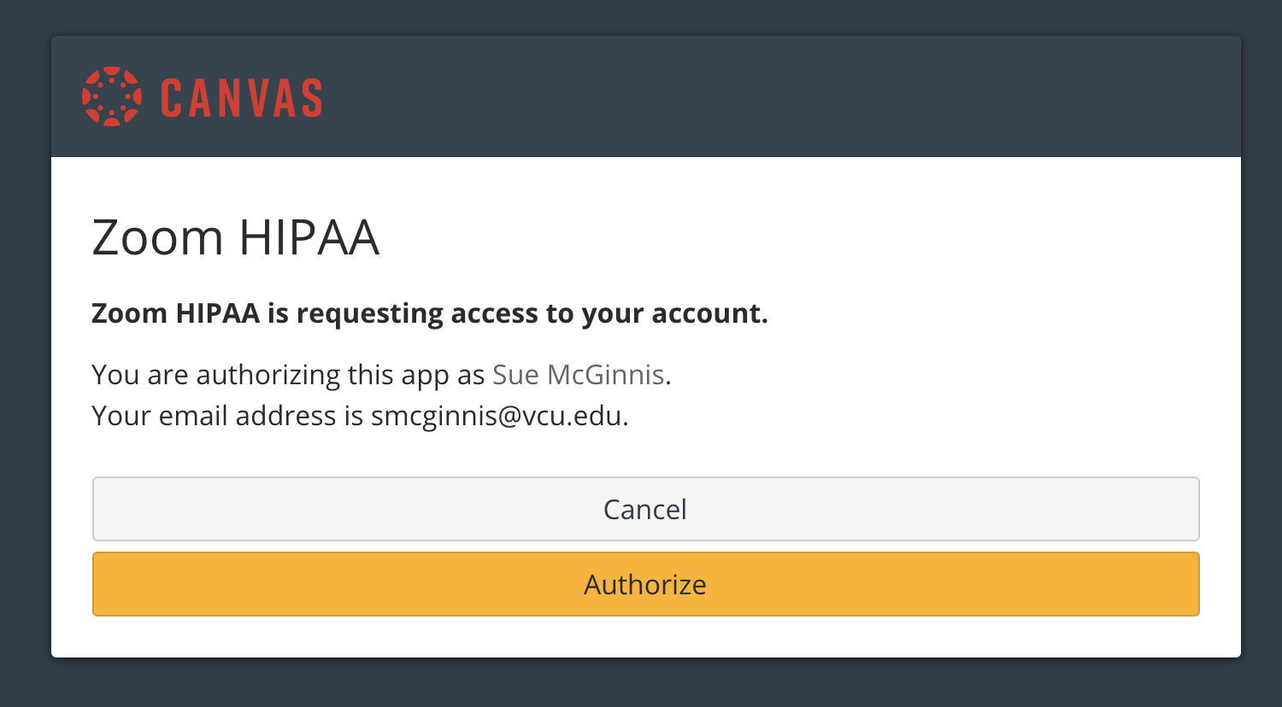

Click Authorize.

You will now go to the Canvas Zoom page. To schedule a meeting for your class, click the Schedule a New Meeting in the top right corner.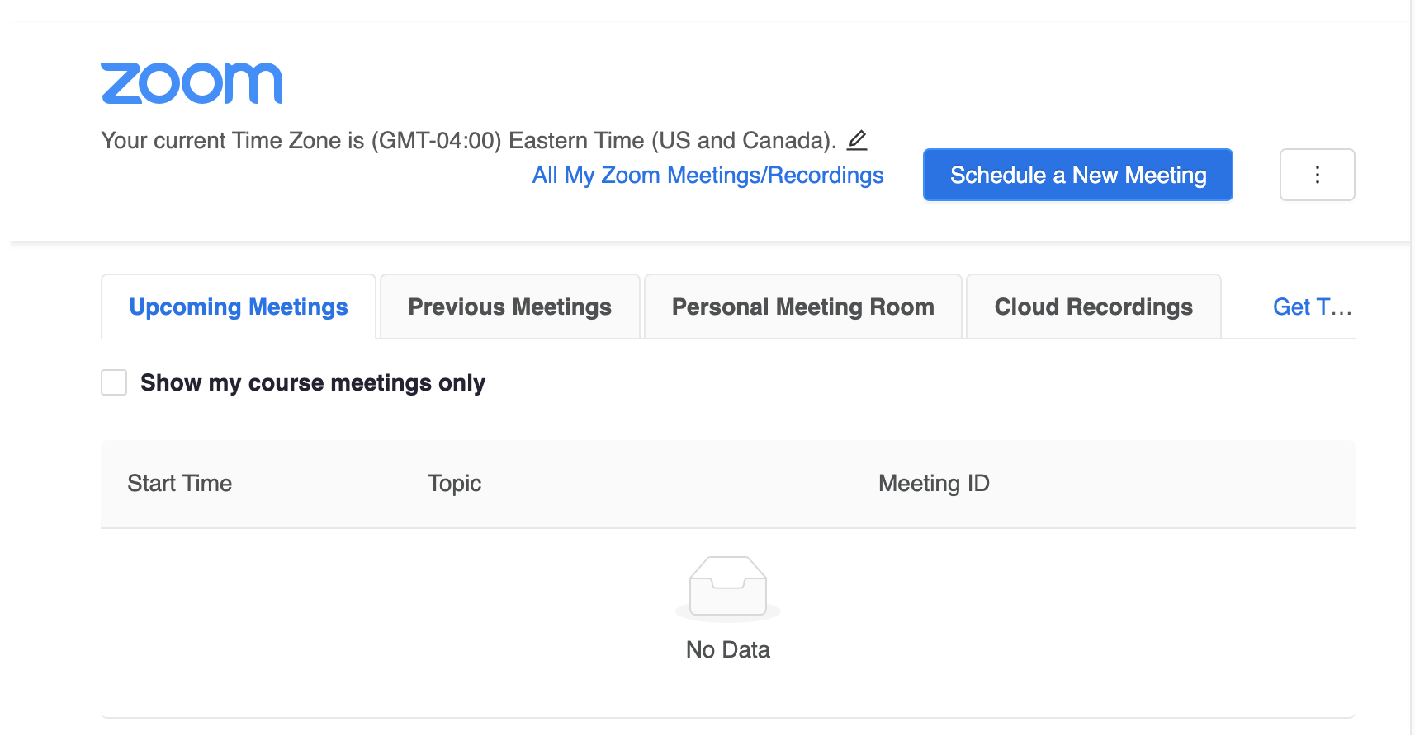

This looks likes the usual Zoom meeting screen. The Topic for the meeting will be the name of the course by default. If you wish to have recurring meetings for class, make sure to choose the "recurring meeting" option.
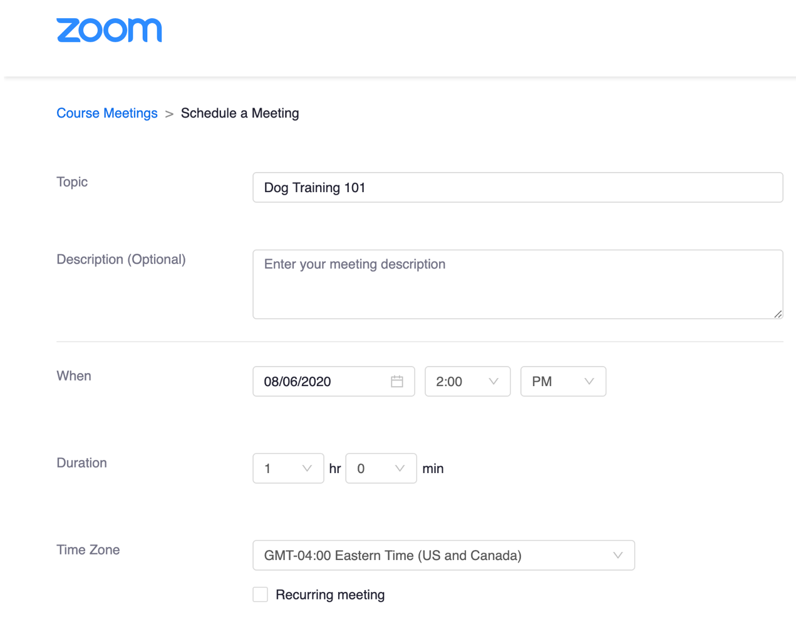

When you have set up your course meeting, it will be available to you when you log into Zoom at https://vcu.zoom.us. If you have set up recurring class meetings, you may want to log into Zoom and change each meeting day to a different topic that matches your syllabus.

Now when you click the link Zoom – HIPAA, you will see your course meeting listed.

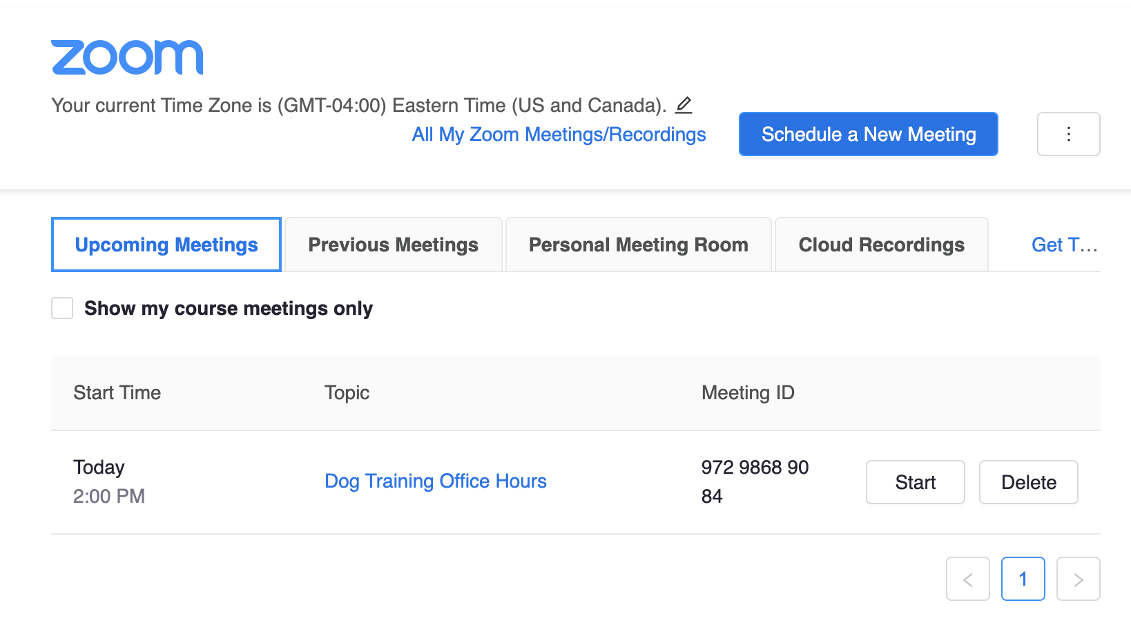
Students can see all meetings for the course by clicking the link in Canvas. Any co-instructors will also be able to join via Canvas.

