VCU Interview Stream

- Go to https://vcu.interviewstream.com and register for an account.
- Once you log in you will be taken to the Home screen:
- 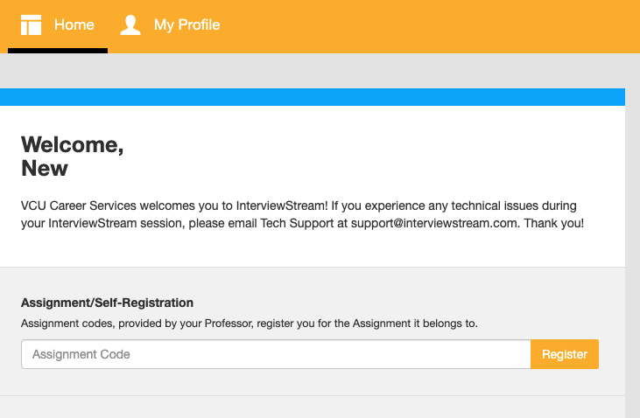

- Copy and paste the assignment code you've been given by your instructor into the box and click Register.

- You will then be taken to the assignment.
- 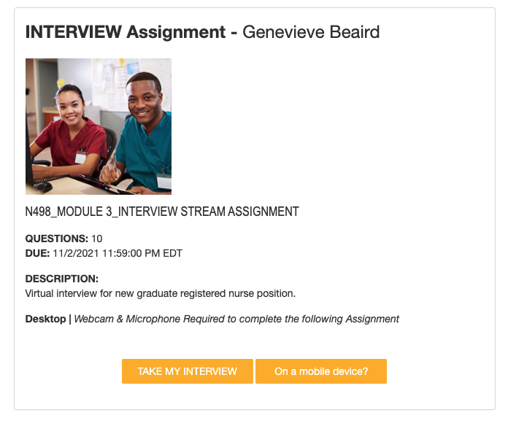
- Once you click "Take My Interview" you will go through a hardware check on your computer. In the first step, you need to allow vcu.interviewstream.com access to your camera and microphone.
- 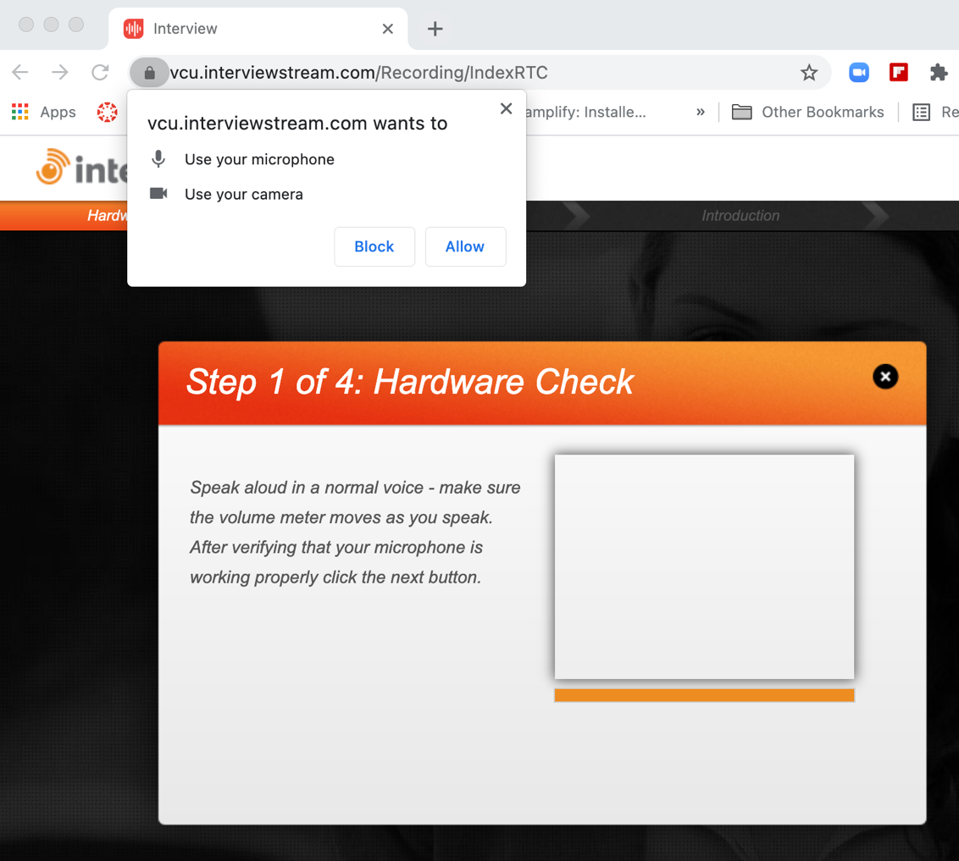
- Once you allow access, you will see your video on the screen. You will see a volume meter move when you speak.
- 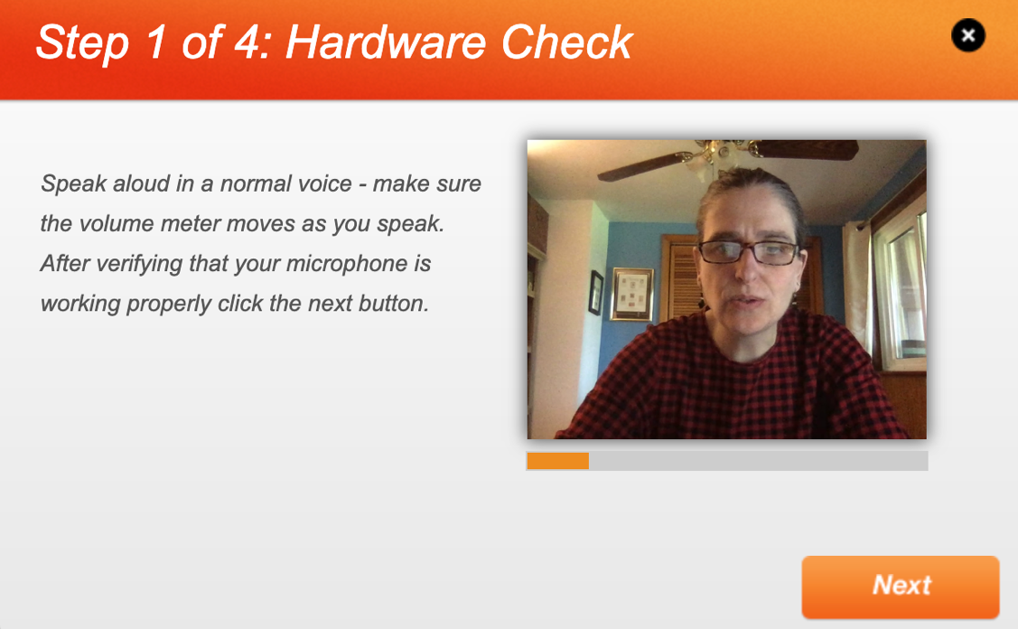
- 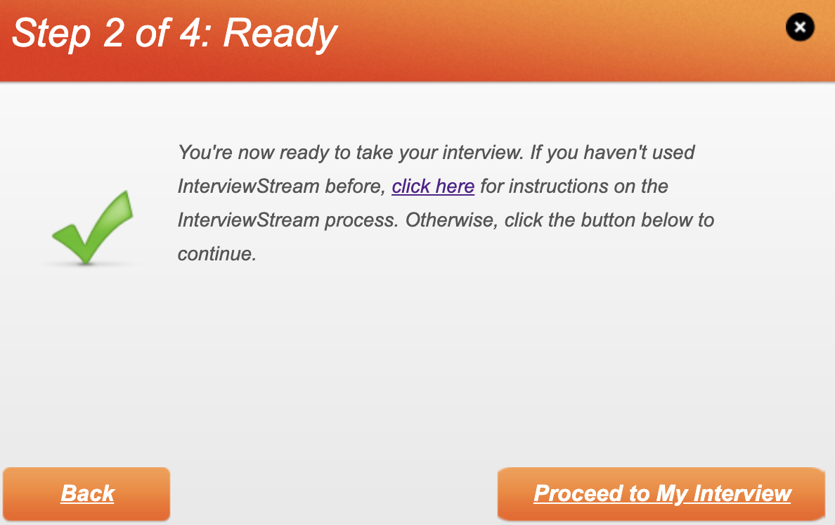
- You will now get a screen that checks to see if you are ready. The text for the instructions for the InterviewStream process reads as follows:

On clicking the "Proceed to My Interview" button, you will be shown an introductory video. Once the video has finished playing, and you are ready to continue, you may click the "Proceed to First Question" button to start the InterviewStream process.

Each question will be presented to you in video form. After the video has finished playing there will be a 3 second countdown before recording will begin, shown below the video. The countdown message will change to let you know that video is now recording, and will update to tell you how much time is remaining. If you do not want this message to display, select the checkbox below.

I do not wish to be informed of the time remaining.

After answering the question to your satisfaction, click anywhere on the screen or press any key to finish recording.

After you have finished recording a response, you will be given the ability to review your response, re-record your response if you so choose, or continue on to the next question.
After you have answered all questions, an exit video will play and your responses will be submitted. At the end of this process, you will be presented with the option to view your interview in full, return to the homepage, or log out.

- You will be asked to record your answers to several questions you may be asked in your first interview for a nursing job. You will have the opportunity to review each of your answers and to view your entire interview.
- Once you have completed all questions, you will be given notification that you can view your interview, return to the home screen or log out.
- 