Download your Canvas Gradebook

It is always a good idea to have a copy of your gradebook at the end of the semester.*

Step 1
Log into your course and click Grades from the course menu.
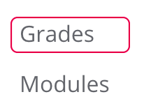

Step 2
At the top of your gradebook, click the dropdown menu next to Actions and choose Export.
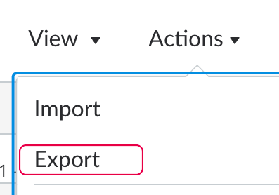

Step 3
At the top of your browser window you will see a confirmation message that the gradebook export has started.

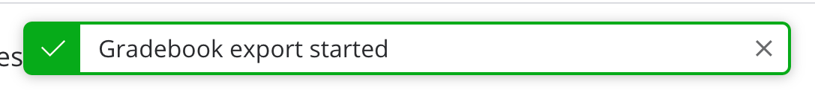

Step 4
A new window will appear and ask where you would like to save your export. Click the Save button and save your gradebook to a safe location.

*According to the VA State Library Records Retention and Disposition Schedule 101069, Academic Departments: Class Rolls and Grade Sheets should be disposed of via confidential destruction 3 years after the end of the semester.

