Download your Blackboard Gradebook

It is always a good idea to have a copy of your gradebook at the end of the semester.* With Blackboard going away May 31, 2021, it is particularly important to back up any gradebooks from courses taught on Blackboard in Spring 2021.

Step 1
Log into your course and click Grade Center > Full Grade Center from the course menu.
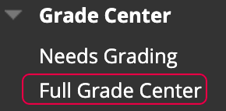

Step 2
In the right corner of your screen of the Grade Center, you will see a dropdown arrow. Depending on what color scheme you have chosen for your Blackboard course, you may or may not see the words "Work Offline" until you hover over them. Choose Download.
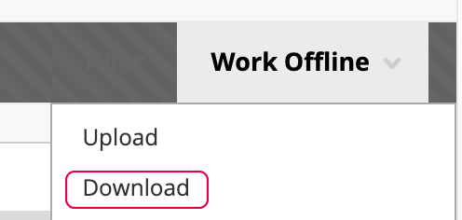

Step 3
The next step asks for the type of data that you would like to download. Choose "Full Grade Center." (It doesn't matter if you choose Tab or Comma for your Delimiter Type.)
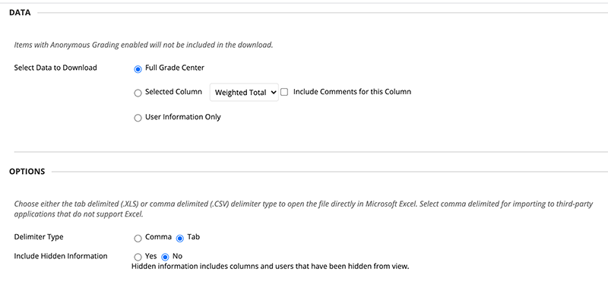

Step 4
Hit the Submit button at the bottom of the screen. Click the Download button on the next page and save your gradebook to a safe location.
*According to the VA State Library Records Retention and Disposition Schedule 101069, Academic Departments: Class Rolls and Grade Sheets should be disposed of via confidential destruction 3 years after the end of the semester.

