Accessing Content on Elsevier Evolve

It is possible to create direct links to Evolve content from a Canvas course. Students are required to purchase the Evolve Clinical Skills Collection in NURS 202. This is a great resource that the students can use throughout nursing school. Many courses beyond NURS 202 will link to this content. In order to see the content as a clinical instructor, you will need to create an Evolve account and request access.

Steps to Create your Evolve Account

- Go to https://evolve.elsevier.com/cs/store?role=faculty
- Click the Sign in link in the upper right corner. 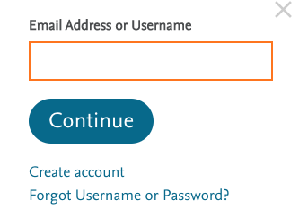
- Click the create account link if you do not have an Evolve account. If you do have an Evolve account, log in with your Evolve user name and password.
- Fill out the form: 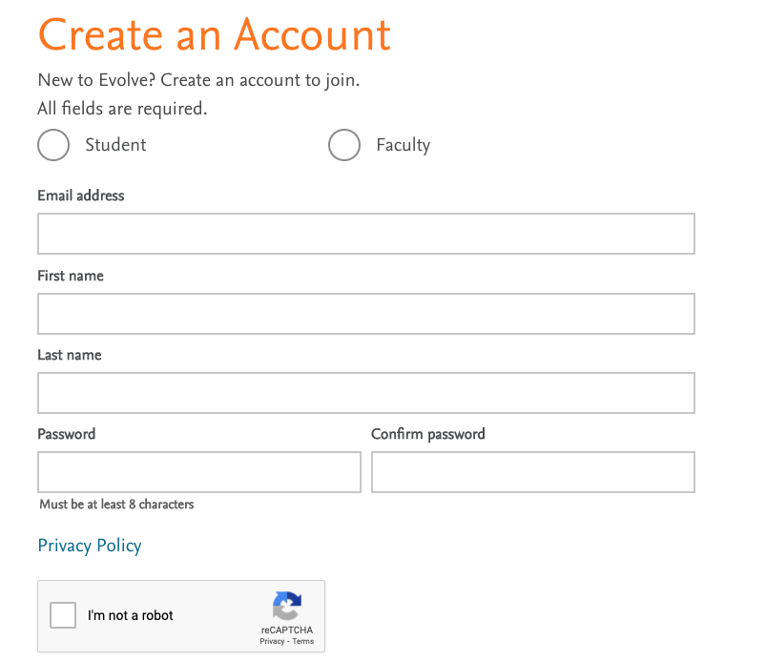
- It may take a day or two to have your account approved as a faculty account.

Steps to Request Access to Evolve Content

- Once you have an Evolve account, log in with your user name and password.
- To request access to resources, click on the "To add more content, visit the catalog" link located at the very top of the page.
- Type in "Clinical Skills: Essentials Collection". The page will look like this: 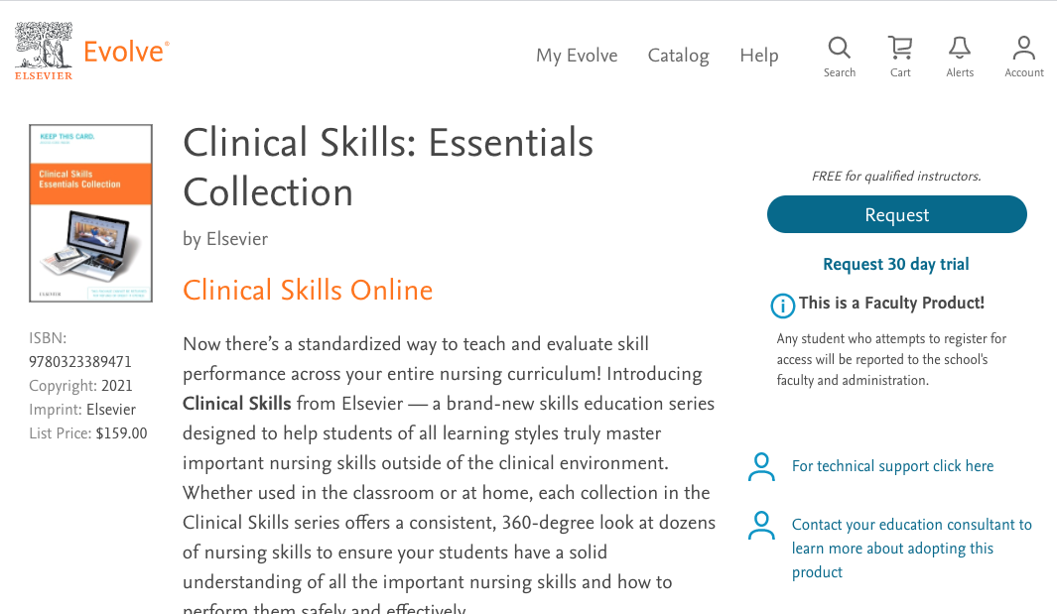
- Click the Request button on the right side to request access to the content. Fill out the form as follows: 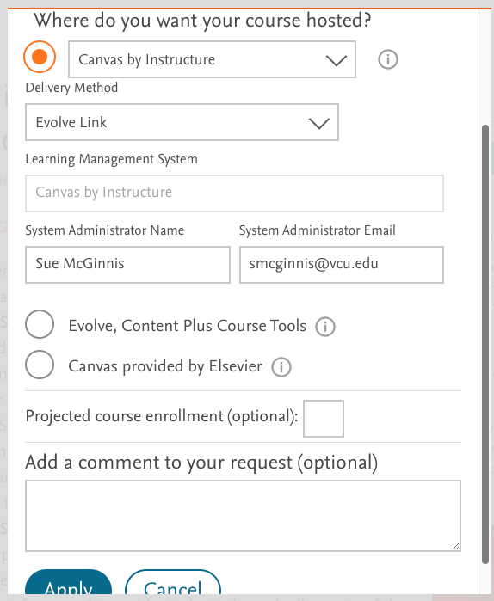
- Click Apply at the bottom.
- On the next screen, click the "Proceed to Checkout/Redeem" button at the bottom.
- After requesting access to the content, you will receive an email that they have received your request. It will take a few days for your request to be fulfilled. Once it is processed, you can access the content by logging into your Elsevier Evolve account or by clicking on the link in your Canvas course.

