Using KMS Go to Take a Video and Post It to Blackboard

For some of your classes you may have to take a video and post a link to your professor for grading. An easy way to do this is to use an app called KMS Go which integrates with VCU’s Kaltura MediaSpace.

Get the App
Go to your device’s app store and search for Kaltura. You are looking for an app called “Kaltura MediaSpace Go.” You can click the name of an app to see a more detailed description. There are a number of Kaltura apps, so make sure you are installing the correct one.

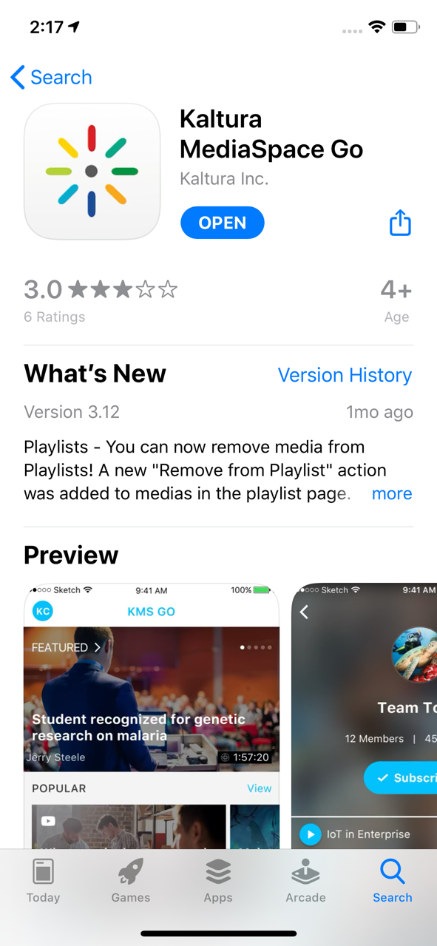

Once you install the app, it will ask for access to your camera and microphone – allow this. It will also ask to send notifications. Once you have agreed, the app will take you to a screen that requests the URL for VCU’s MediaSpace. The screen will look like this:

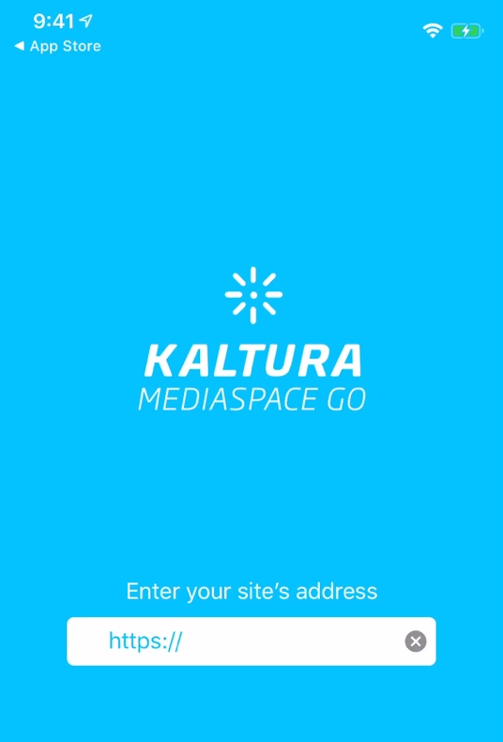 | Put in the URL: https://vcu.mediaspace.kaltura.com

Once you are brought to Kaltura MediaSpace, click the upload button.

You will then be taken to VCU’s CAS authentication page to enter your eID, password and to authenticate using DUO.

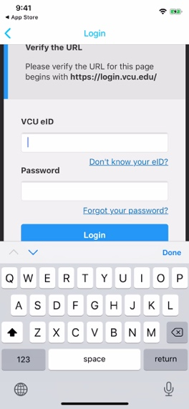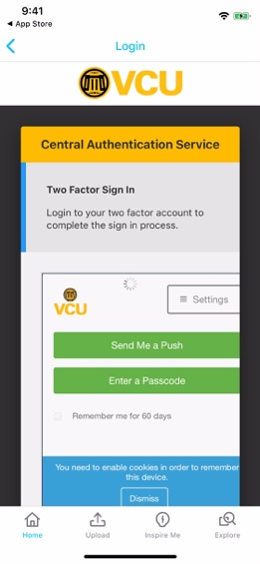

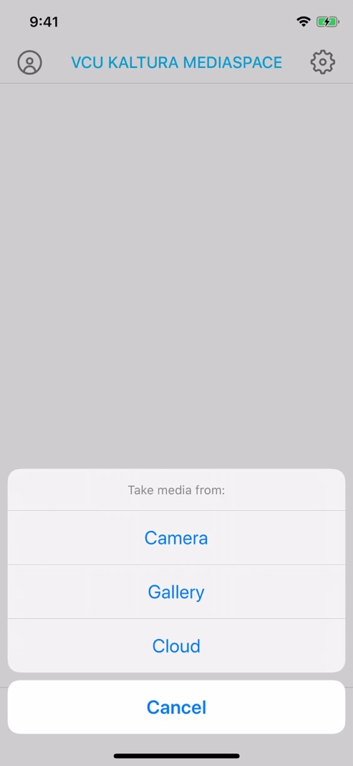 | Press the upload button after authenticating. Choose Camera. Switch over to video and hit the red button to record.

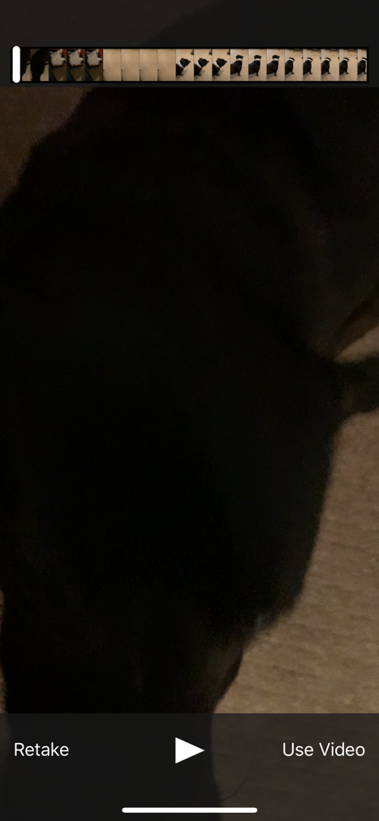 | After shooting the video, you can Retake or Use Video. When you click “Use Video” you will see a preview of your video. When you are finished previewing the video, click Done in the upper right corner.

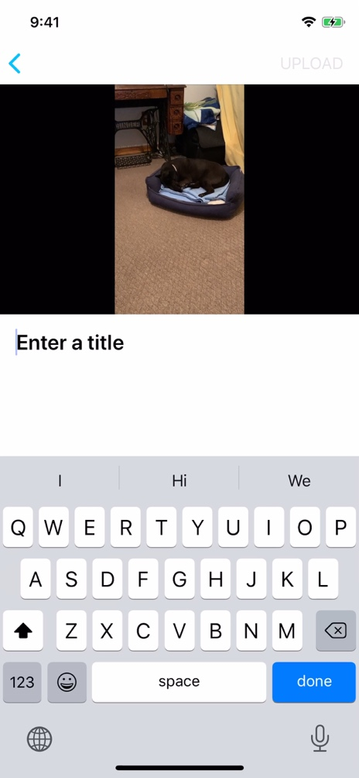 | Enter a title for your video and click the done blue button in the lower right corner.  Now, hit the blue UPLOAD link in the upper right corner.
 | Read and accept the disclaimer by clicking the blue OK link in the upper right corner.
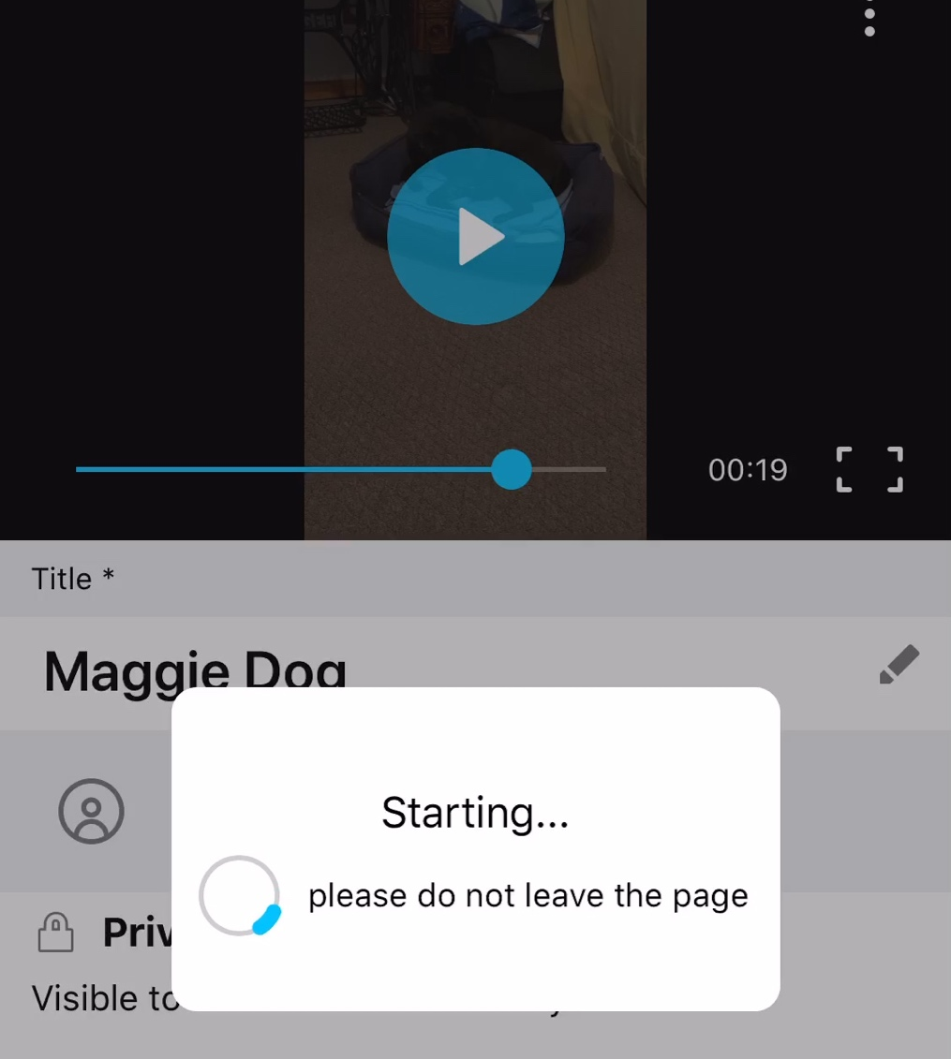 | Your video will then begin to upload. The amount of time it takes to upload will vary based on video length and your Internet connection.
 | After the video uploads, it will ask if you would like to Publish now…choose YES.
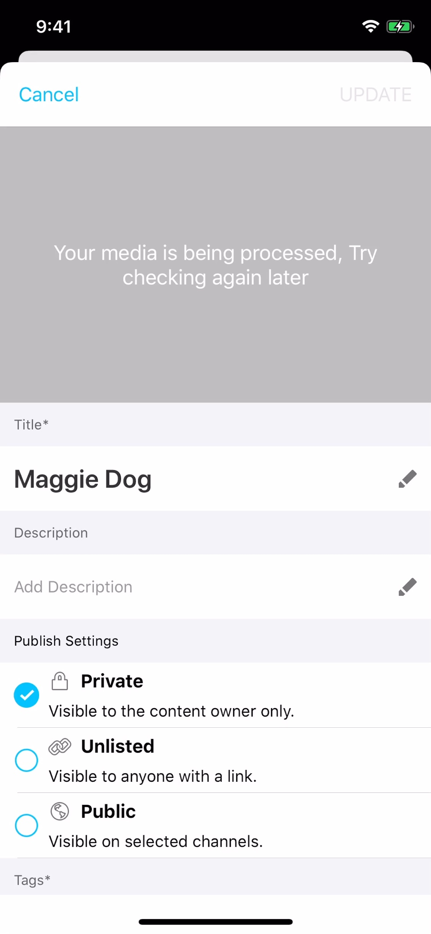 | The video will publish for some time. In order to send a link to your professor for grading, you will need to change the publish settings to unlisted. This will allow the video to be visible to anyone with the link.  After changing to Unlisted, add a tag to the video for a description and click the blue UPDATE link in the upper right corner.
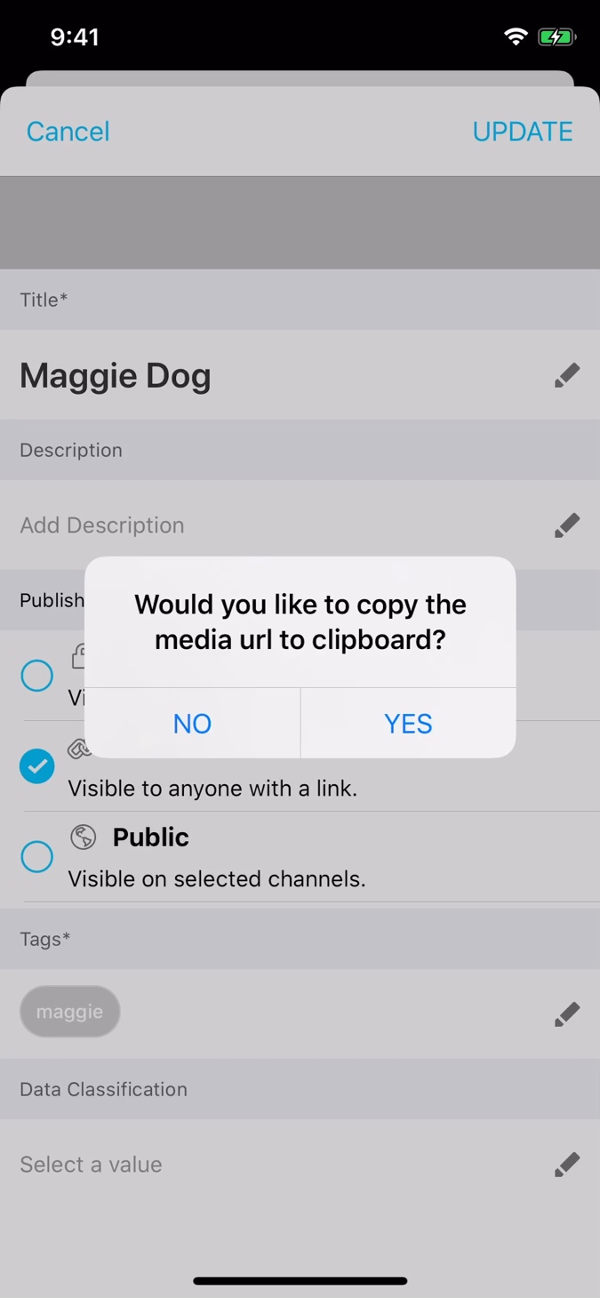 | You will then be asked if you want to copy the media url to the clipboard. Choose YES. Create an email to send to yourself and paste the link into the email. This is the link that you will post in Blackboard.

