Recording a Class Using Zoom and Posting the Recording to Blackboard

Setting up the recording

There are two ways to set up a recording of a Zoom meeting or class: either manually when the meeting starts or you can set your preferences to automatically record when the meeting starts.

Manual Recording

To start recording as the host, you will see a Record button on your Zoom toolbar. 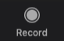
When you click the button it will turn into a Pause/Stop Recording button. 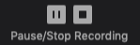 In the upper left corner of the Zoom window you will get a visual indicator that your meeting is being recorded.

Automatic Recording

If you are recording a number of meetings or classes, you may opt to start the recording immediately when the class or meeting starts. To do this, log into your Zoom account by going to https://vcu.zoom.us and clicking sign in.

Click Settings on the left side of the window and the Recording option in the right middle column. You will see that you can turn on automatic recording as an option. This will record meetings automatically as they start.

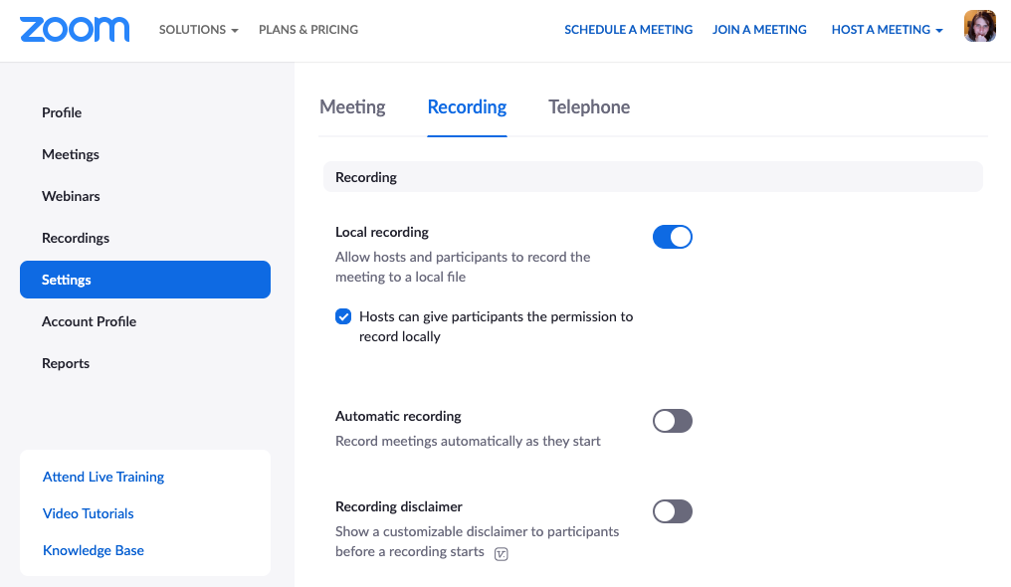

Where are the Recordings?

After you’ve recorded a meeting or class, Zoom will need to convert the meeting recording and a window like this will appear:
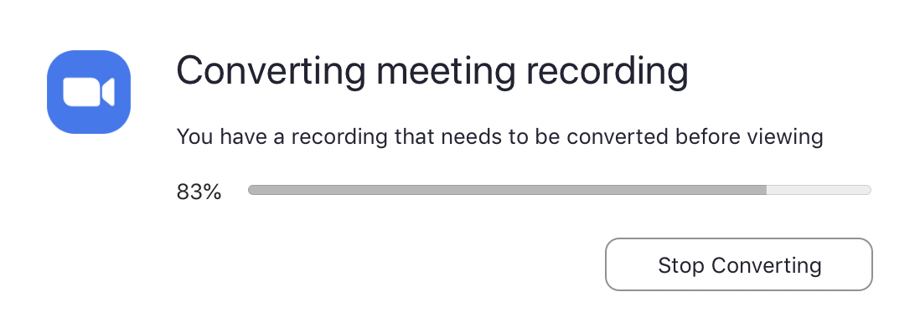
This process will take some time. The longer the meeting, the longer it will take for conversion.

After the file has converted, another window will pop up to show where the recording will be saved. The default location is in the Documents folder on a Mac or Windows computer.

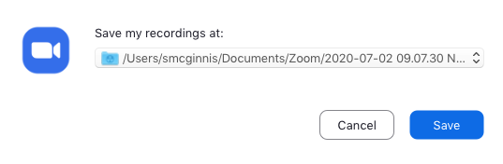

Go to Documents and look for Zoom. Meetings will be listed by date and name of meeting. Each folder will have 4 files. Chat.txt is the chat transcript and zoom_0.mp4 is the file that you will upload to Kaltura to post to Blackboard.

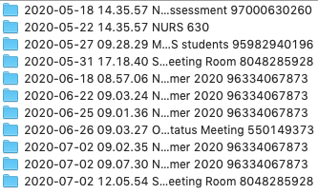 | 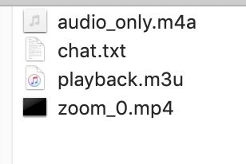

Posting to Kaltura

The mp4 files that are created by Zoom can be very large and it is best to post them to Kaltura to convert them to a streaming file before posting them into your Blackboard course.

Log into Kaltura by going to https://go.vcu.edu/kaltura
Click on the + sign or +Add New link and choose Media Upload.
Drag and drop the zoom_0.mp4 file or browse to select the file.
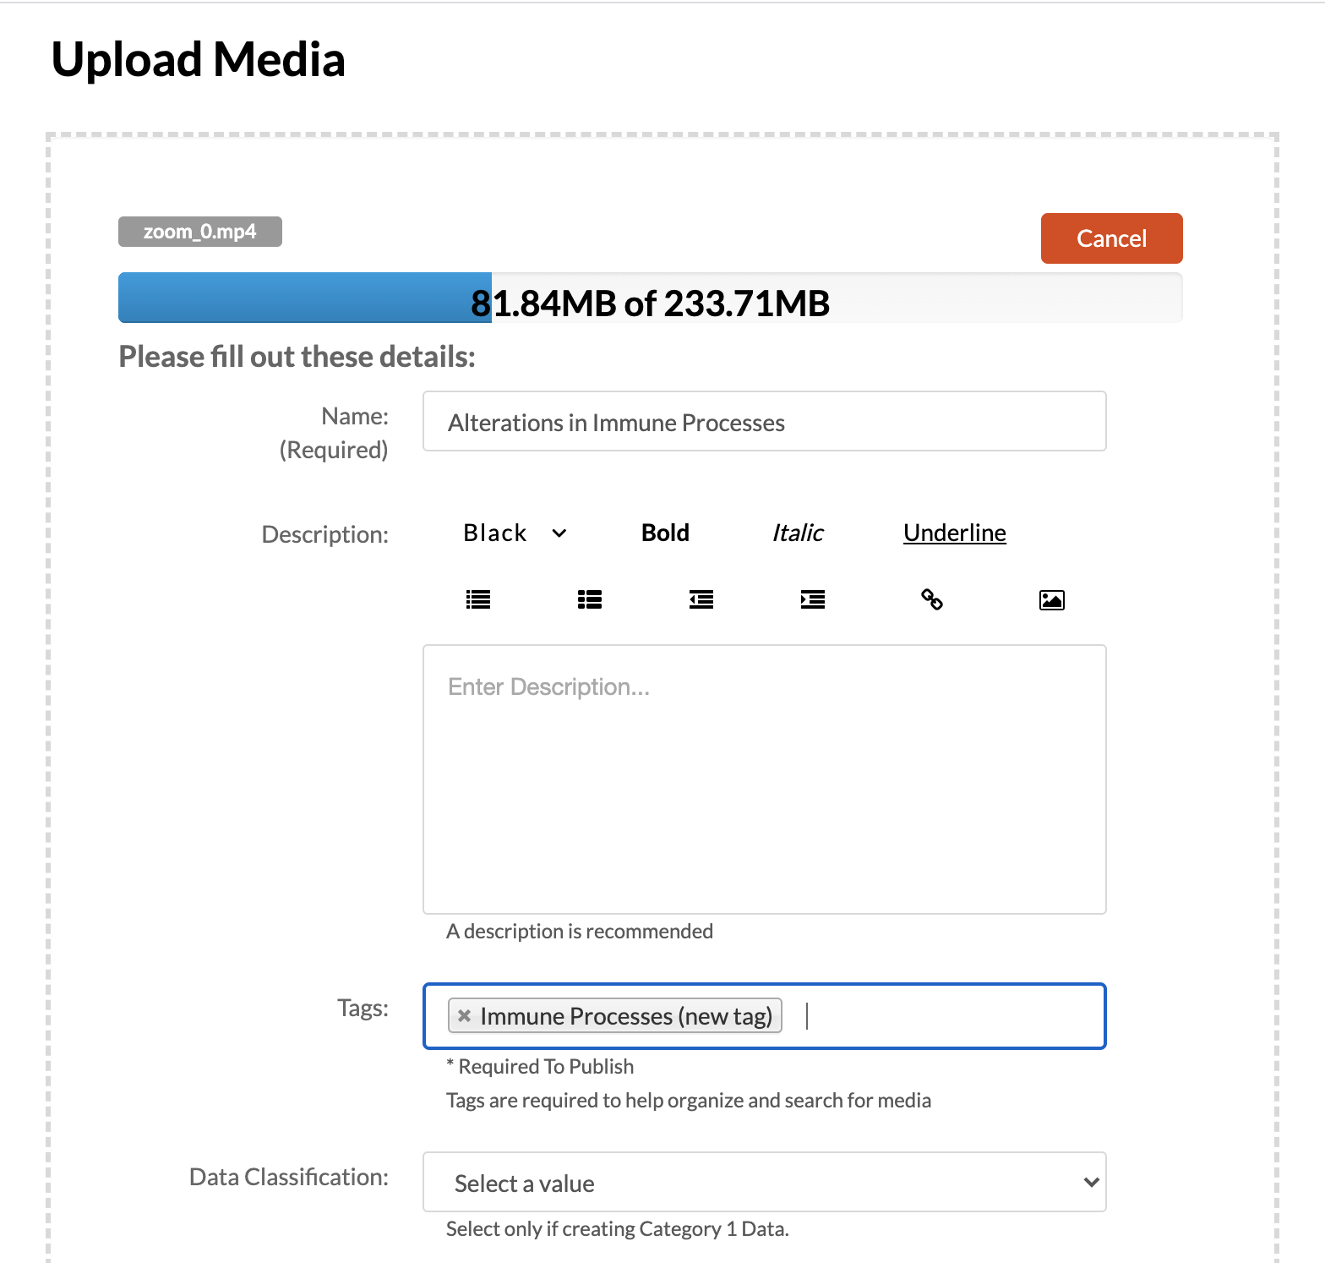

It will take a bit for the file to upload. After the file uploads, it will need to process. This can take several hours, depending on the size of the file. After the file uploads, click the go to media link. You will see an image that looks like this:

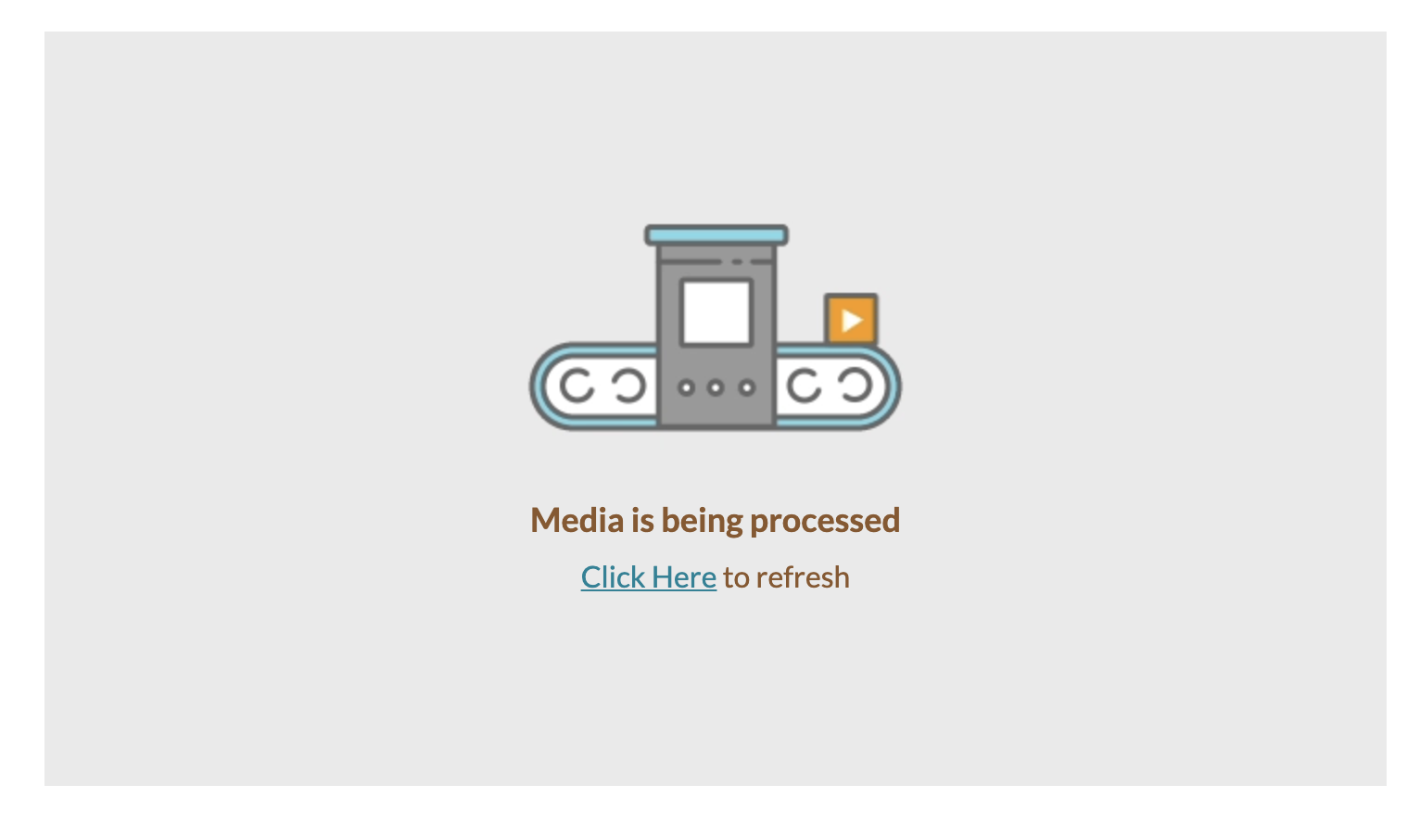
Every hour, click the “Click Here” to refresh to check if the file has been processed.

Adding the Kaltura Video to Blackboard

To add the Kaltura video to Blackboard, go to any content area and choose Build Content > Item.

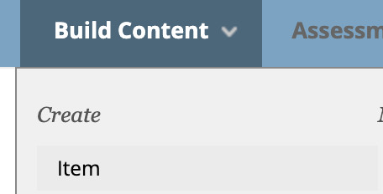

Give your item a name and click the arrow next to Mashups to choose Kaltura Media.

Find the video you wish to post and click the Select button to the right of the video.
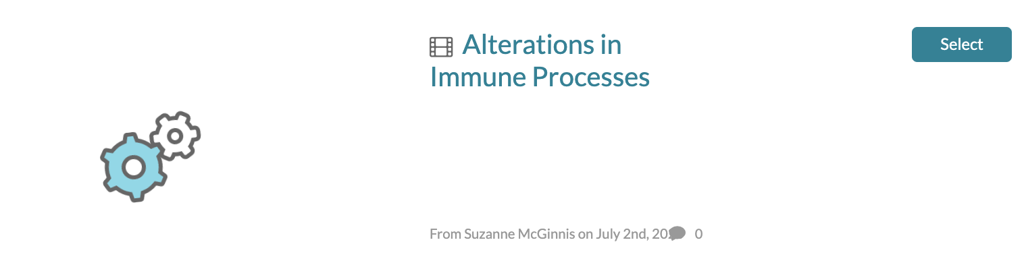
The item will look like this until you hit the submit button:
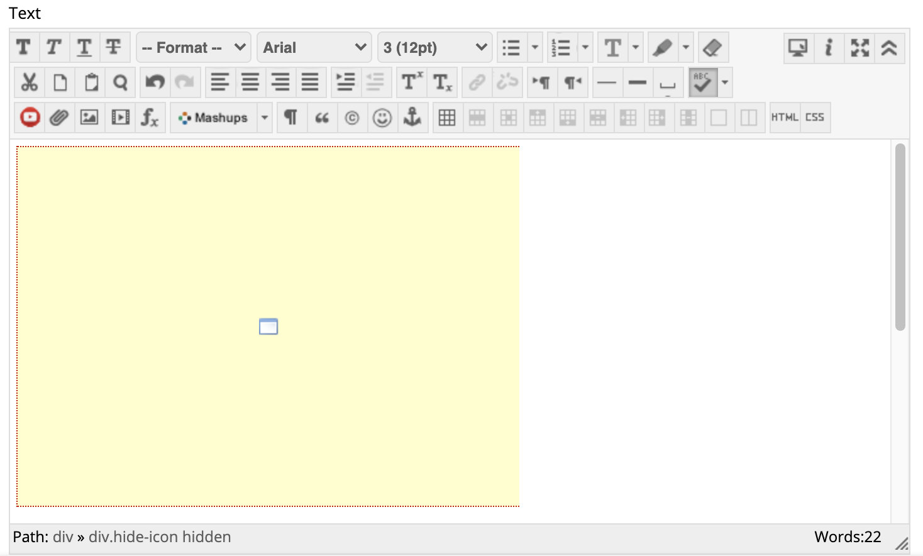

Once you hit the submit button, the video will look like this:

