Zoom and Polling

There have been a few faculty that have asked about using the polling feature in Zoom. To do this, see the instructions below.

Enable Polling in Your Zoom Account Settings

- Log in to the VCU Zoom portal https://vcu.zoom.us with your eID and password.
- Click on your name in the upper right corner so that you can view your account preferences.
- 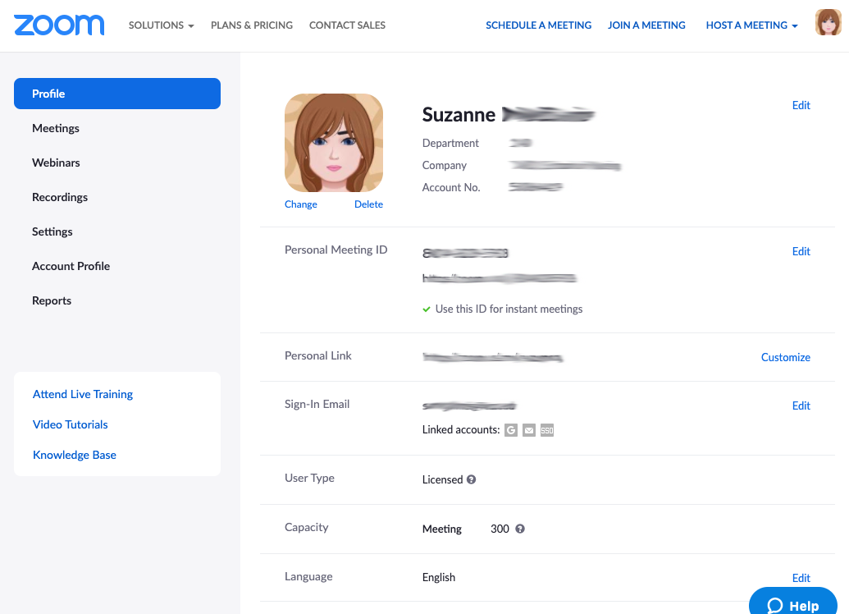
- Go to the settings menu item on the left and scroll down to Polling. Make sure this is on.

Using Polls in Meetings

About Zoom Polling:

- Go to the Meetings page and click on your scheduled meeting. (Log in to Zoom and click the Upcoming Meetings menu item.)
- Click on the name of your scheduled meeting.
- From the meeting management page, scroll down to the bottom to find the Poll option and click Add to begin creating the poll.
- 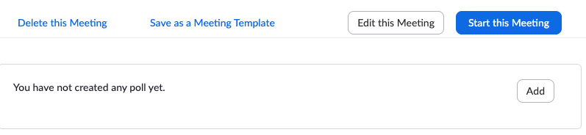
- Name your poll and add your questions.
- You can choose to have a single choice answer or a multiple answer question.
- When you are done with your poll, click the Save button at the bottom.
- If you wish to create additional polls, click the Add Poll button to create a new poll.
- 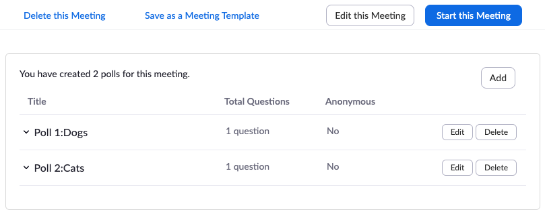
- Start the meeting. When you are ready, click the polling button at the bottom. 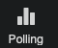
- The polling box will appear. To launch a poll, click the launch poll button.
- To switch between the polls, click the arrow at the top of the polling screen. 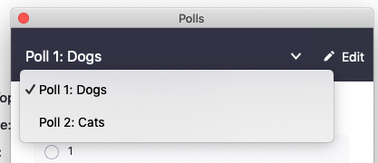

For more about Zoom polling, see the following resources from the Zoom website:

- Polling for meetings
- 3 Ways to Use Polls in Meetings

