Zoom and Breakout Rooms

There have been a few faculty that have asked about using the breakout room feature in Zoom. To do this, see the instructions below.

Enable Breakout Rooms in Your Zoom Account Settings

- Log in to the VCU Zoom portal https://vcu.zoom.us with your eID and password.
- Click on your name in the upper right corner so that you can view your account preferences.
- 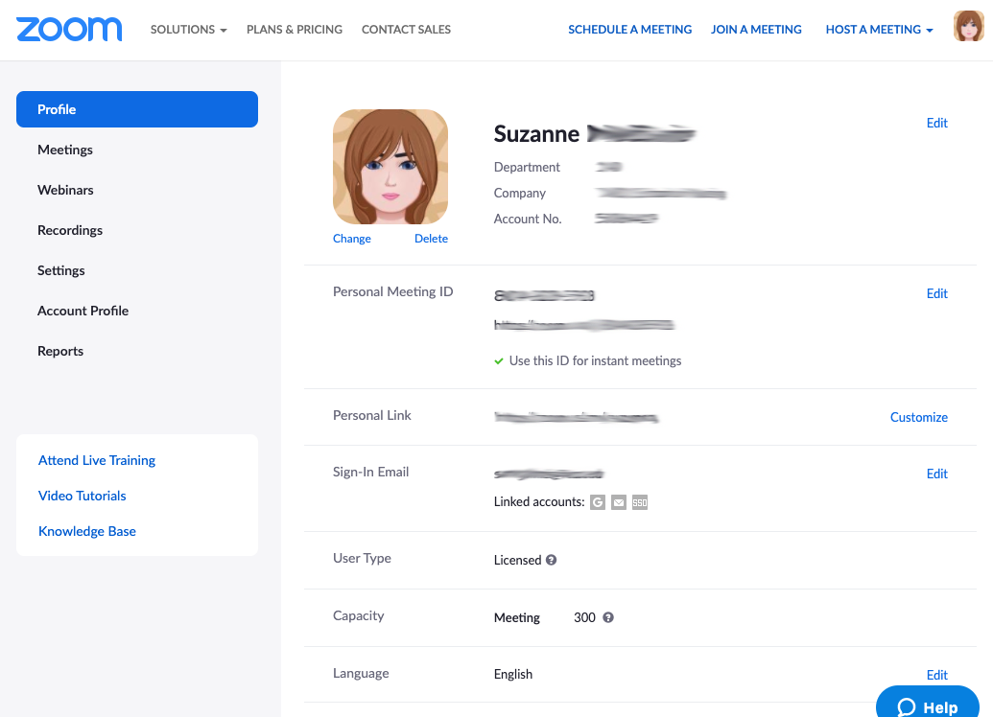
- The first tab is your profile where you can change how your name appears and the picture that displays when your in meetings and turn off your video.
- Go to the settings menu item on the left and scroll down to the "In Meeting (Advanced)" section and choose the first item: Breakout room. Make sure that this toggle is blue.
- 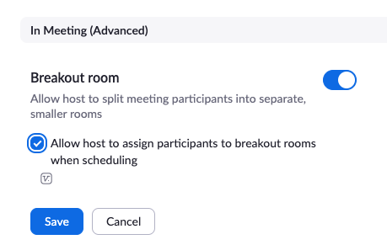

Using Breakout Rooms

About Zoom Breakout Rooms:

- You can pre-assign participants to breakout rooms when you schedule the meeting instead of managing them during the meeting.
- Breakout room participants have full audio, video, and screen share capabilities.
- There are some limitations:
  - There is a limit of up to 50 breakout rooms for up to 200 participants
  - When recording is used, it will record the room the participant who is recording is in.

For more about Zoom breakout rooms, see the following resources from the Zoom website:

- Managing breakout rooms
- Pre-assigning participants to breakout rooms
- Enabling breakout rooms

