Installing Kaltura capture software

Step 1: Go to the VCU Kaltura website and Login
- Open a web browser and go to: https://go.vcu.edu/kaltura

- Click the Login to Kaltura button in the middle of the page.
- After clicking the blue button, you will be brought to another page that looks like this:
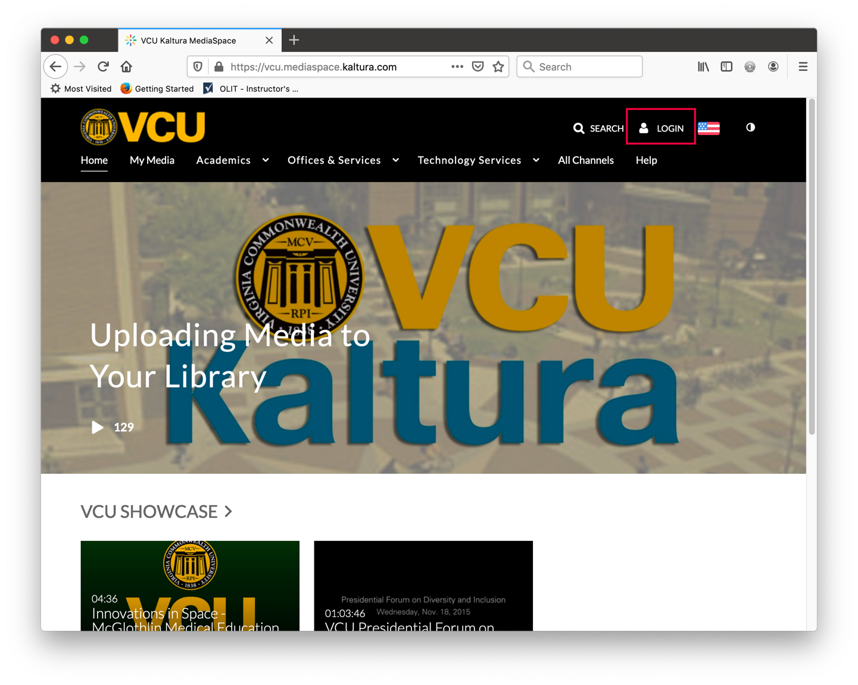
- Click the LOGIN item at the top of the screen and Login in the menu.
- Phew! That's a lot of login clicks! After the last login click, you will be taken to the Central Authentication Service page to enter your eID and password.
- You will be taken to your home page on the Kaltura server. The top will look like this:

Step 2: Install the Software

- Click ADD NEW from the menu.
- Choose Kaltura Capture 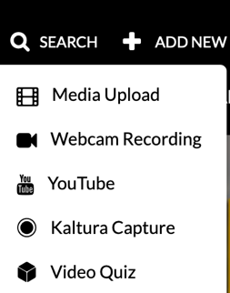
- A new window will pop up and ask you to agree to the terms and conditions of posting videos at VCU. You must agree to the terms.
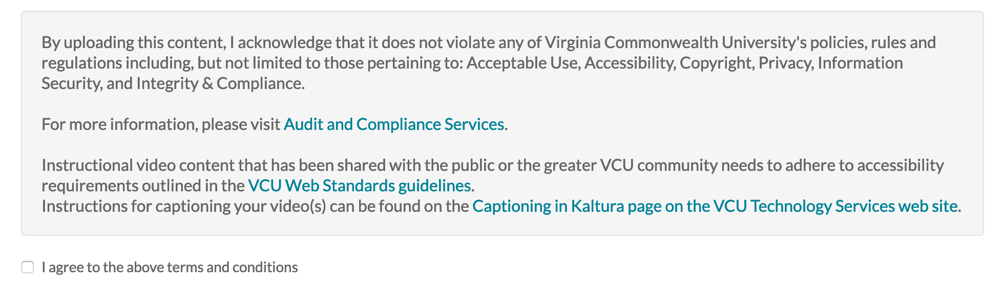
- Once you click the "I agree to the above terms and conditions" another window will open that looks like this:
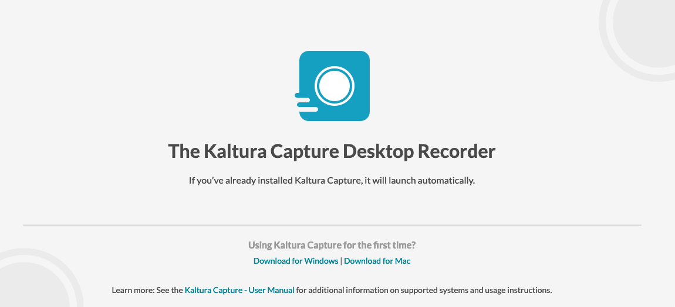
- Choose Download for Windows | Download for Mac depending on your operating system. You do not need to have administrative privileges to complete the installation.
- Once the application has been installed, follow the next set of instructions to create your lecture.

