How to Host Zoom Meetings from Blackboard

Enable the Tool (if it isn't already available)

- Go to Tools/Communications on the course menu and look for the tool.
- If you do not see it available in Tools, you will need to enable it for your course.
- To do so, Click Customization > Tool Availability
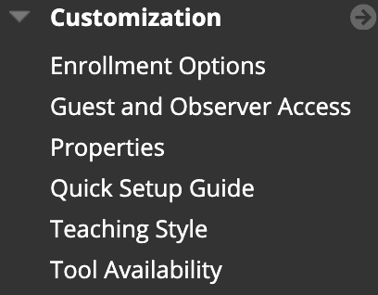

- In the Tools area, you will see a list of over 150 different tools that you can turn on or off for your course. These are what display or do not display when you click on Tools in the course menu.
- Scroll down to the bottom and make sure that there is a check next to Zoom – HIPAA/MCV. Remove the check for Zoom Meeting. This is for the MPC campus only. It should look like this:

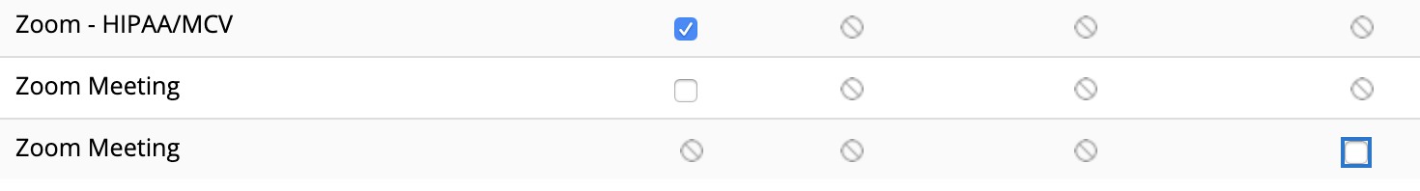
- Once the Zoom – HIPAA/MCV tool is enabled, you will find it in your course menu under Tools/Communications.

Schedule a Meeting

- Log in to Blackboard
- If you haven't already, make sure to go to https://vcu.zoom.us and log in with your eID and password to make sure that you have a Pro account. If you have done this previously, you can skip this step.
- Make sure edit mode is on.
- Click Tools/Communications on your course menu
- The very last two options are Zoom – HIPAA/MCV and Zoom Meeting. Choose Zoom – HIPAA/MCV
- You will see a screen that looks like this:
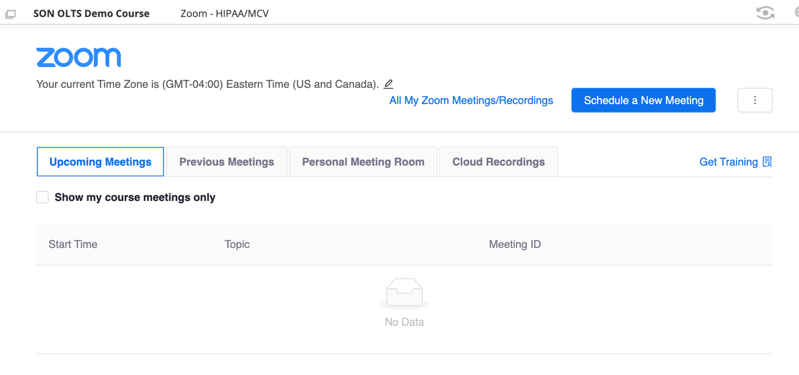
- Click the Schedule a New Meeting button.
- Schedule the meeting as you normally would. If you wish to record the meeting, click the box next to: 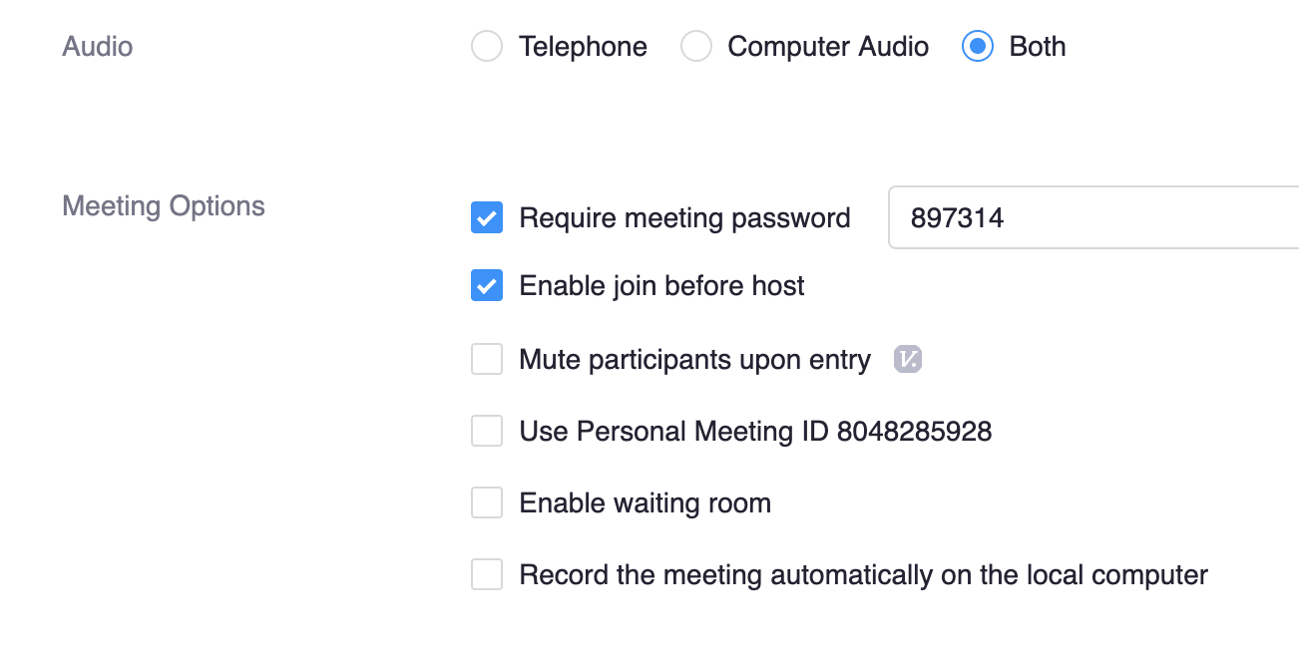Record the meeting automatically on the local computer.
- 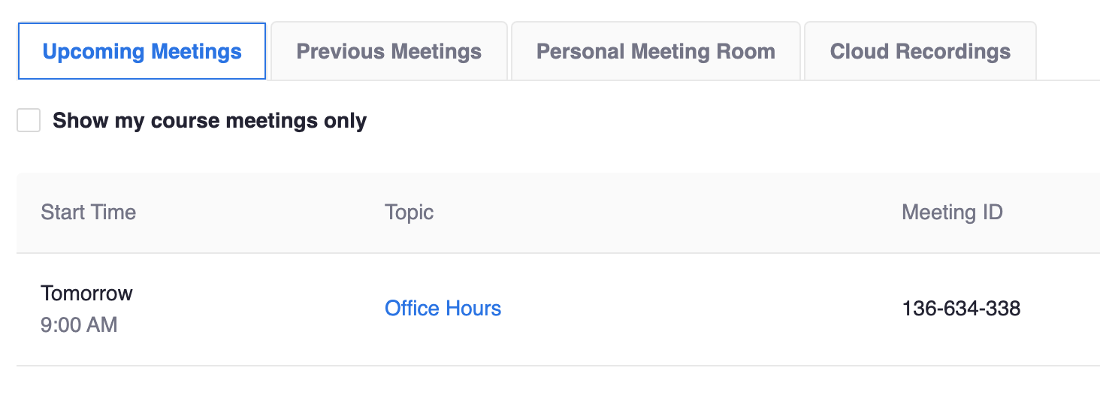
- The instructor will have a start button for any upcoming meetings and the students will have a Join button.
- Cloud Recordings are not available for MCV Campus schools. If you wish to record the meeting, see the additional instructions below.

Recording Zoom Meetings

- To record a zoom meeting, you must be the meeting Host.
- In the zoom meeting you get visual confirmation that your meeting is being recorded.
- When you are finished with the recording, click the stop recording button or press End Meeting. After you end the meeting the file will need to process and save to your local computer. 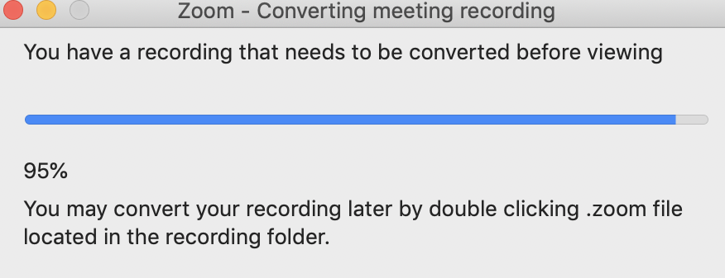
- After conversion, Zoom will ask where to save your recording. The default save location is in Documents> Zoom on Windows 10 and Mac.
- 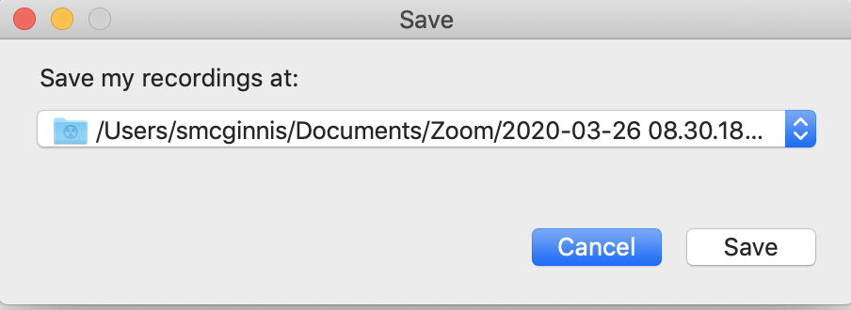

Upload a Zoom Recording to Kaltura

- Open the folder on your local drive for the Zoom meeting you wish to make available to your students on Blackboard. By default, folder names are in this format:
Date of meeting Name of Meeting Meeting ID
- 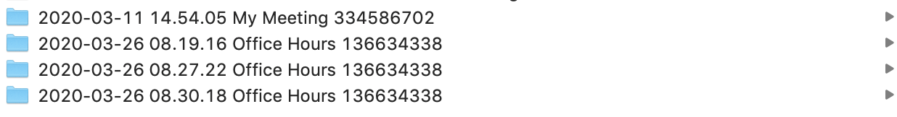
- When opening the folder, you will see three files:
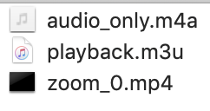
- The file you will upload to Kaltura is the zoom_0.mp4 file.
- Log in to Kaltura by going to: https://go.vcu.edu/kaltura and logging in with your eID and password.
- Once logged in, click the Add New menu item to the left of your name in the top right corner.
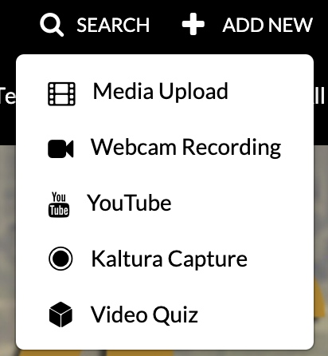
- Select Media Upload.
- Agree to VCU terms and conditions.
- Choose your file. The upload time for the file will vary based on file size.
- Once the file has been uploaded, rename the file from zoom_0 to something meaningful as this is what will display on your My Media page.
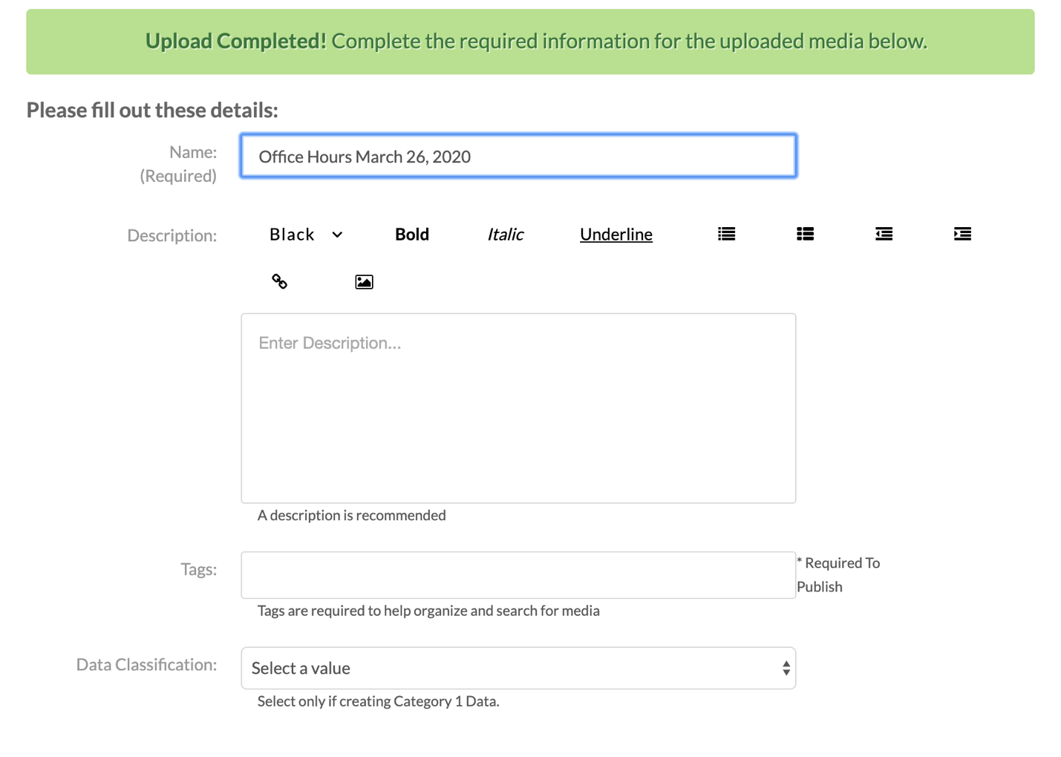
- Scroll to the bottom of the page and click Go To My Media to be taken back to your Media page.
- The file will take some time to process depending on the size of the file. Once the file has processed, you can add it to your Blackboard course.

Add a Video from Kaltura to Blackboard

- Go to any location in your course: Course Modules, Announcements, Discussion Board.
- Create a new item, announcement, or discussion board post.
- 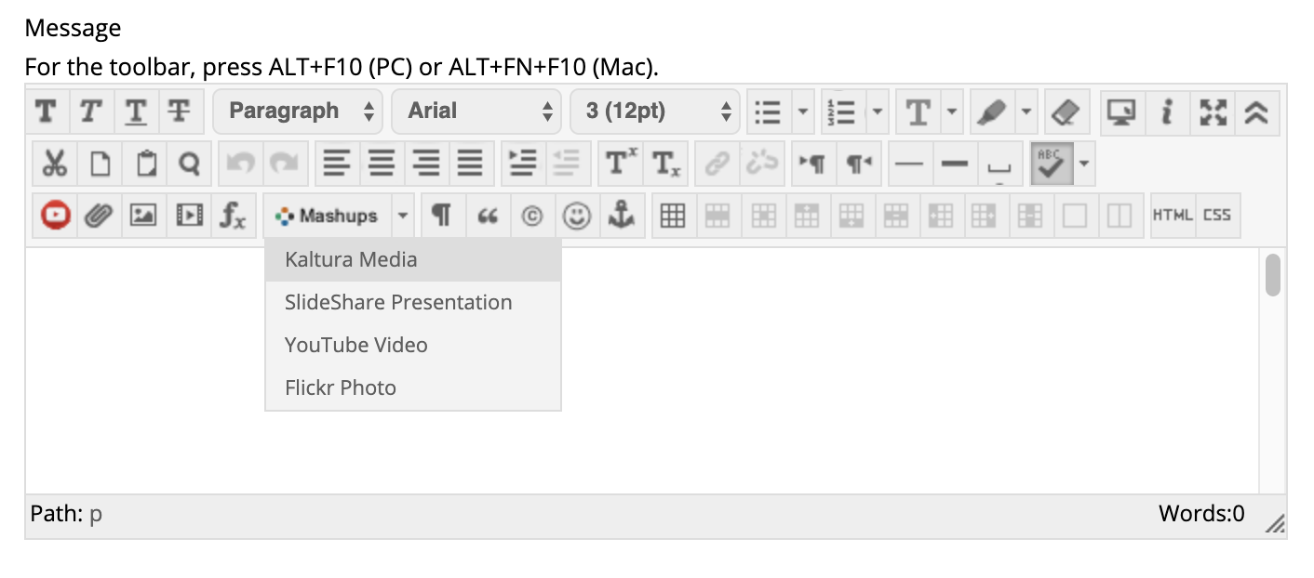
- Anywhere you have a WYSIWYG toolbar in Blackboard, you will have the Mashups button available. Click this button and you will see the above screen.
- Choose Kaltura Media to add your Zoom recording.
- You will be taken to your Kaltura My Media page where you will be able to select the video.
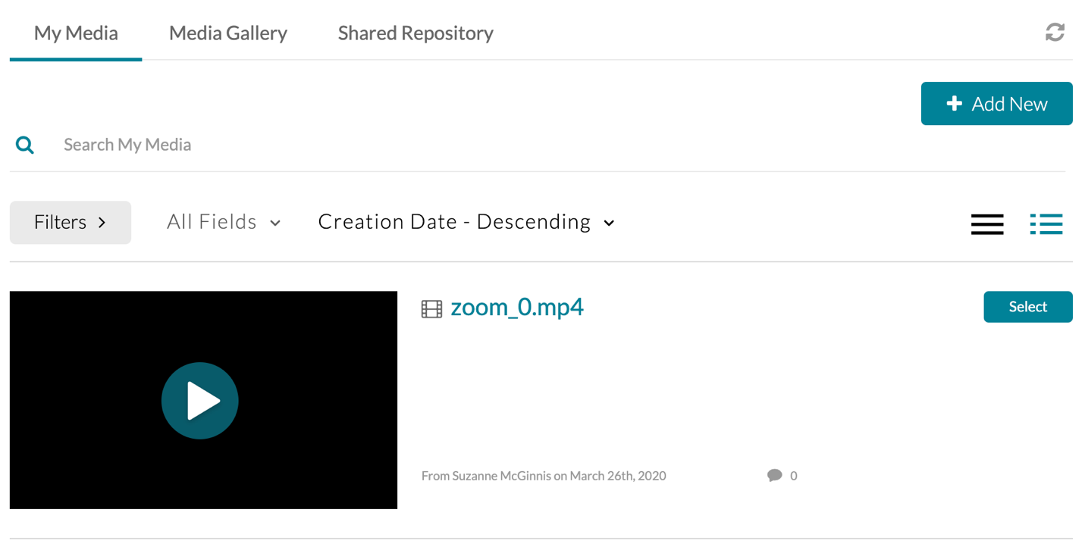
- Press the Select button to select the video.
- It will look like this on your screen:
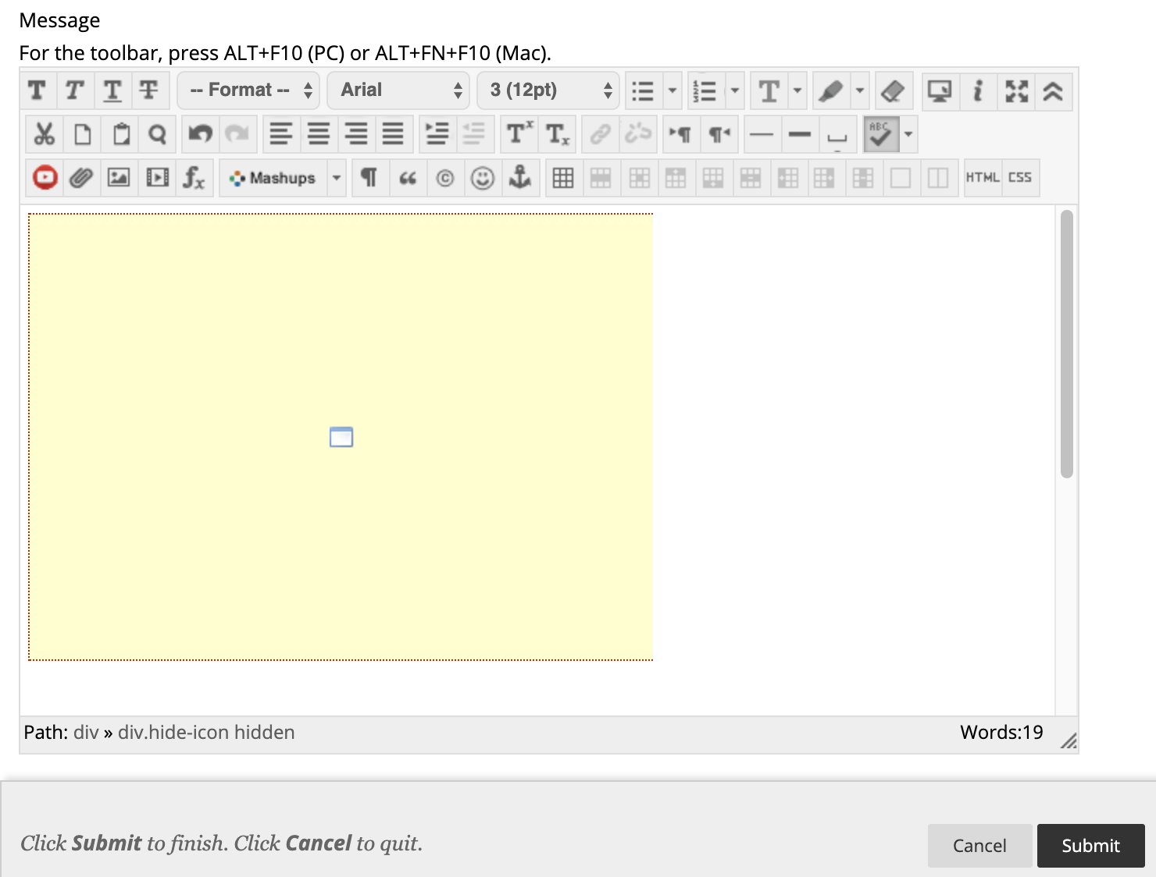
- Press the Submit button.
- Your video will appear embedded in your content.
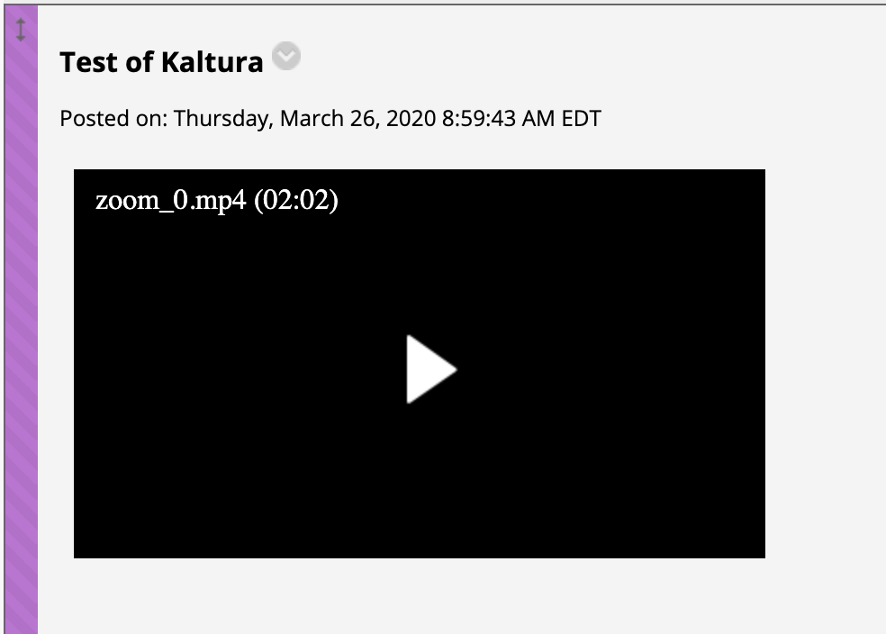

- Please note: you will be unable to select a video until it has finished processing. It is best to upload your Zoom recording and to let the recording process for a few hours before adding it to your Blackboard course.

