How to Use VoiceThread to Create a Lecture

VoiceThread is a tool that allows you to create voice over PowerPoint, audio, video or text presentations. You or your students can create or comment on VoiceThreads. The steps below will walk you through it.

What is a VoiceThread?
A VoiceThread is a way to have multimedia discussions about a topic, document, image or video. You can upload a PowerPoint to VoiceThread and comment on each individual slide.
More on what a VoiceThread is….https://www.youtube.com/watch?v=arB74zm6DPs

VoiceThread workshops: https://voicethread.com/workshops
Using VoiceThread to Enhance Existing Assignments – this is a guest blog post by our own Kimberly Davis who posted to the VoiceThread Blog. https://voicethread.com/blog/using-voicethread-to-enhance-existing-assignments/

How do I Create a VoiceThread?
Log in to the VoiceThread server: https://go.vcu.edu/voicethread
Log in with your eID and password.

Your VoiceThread Homepage
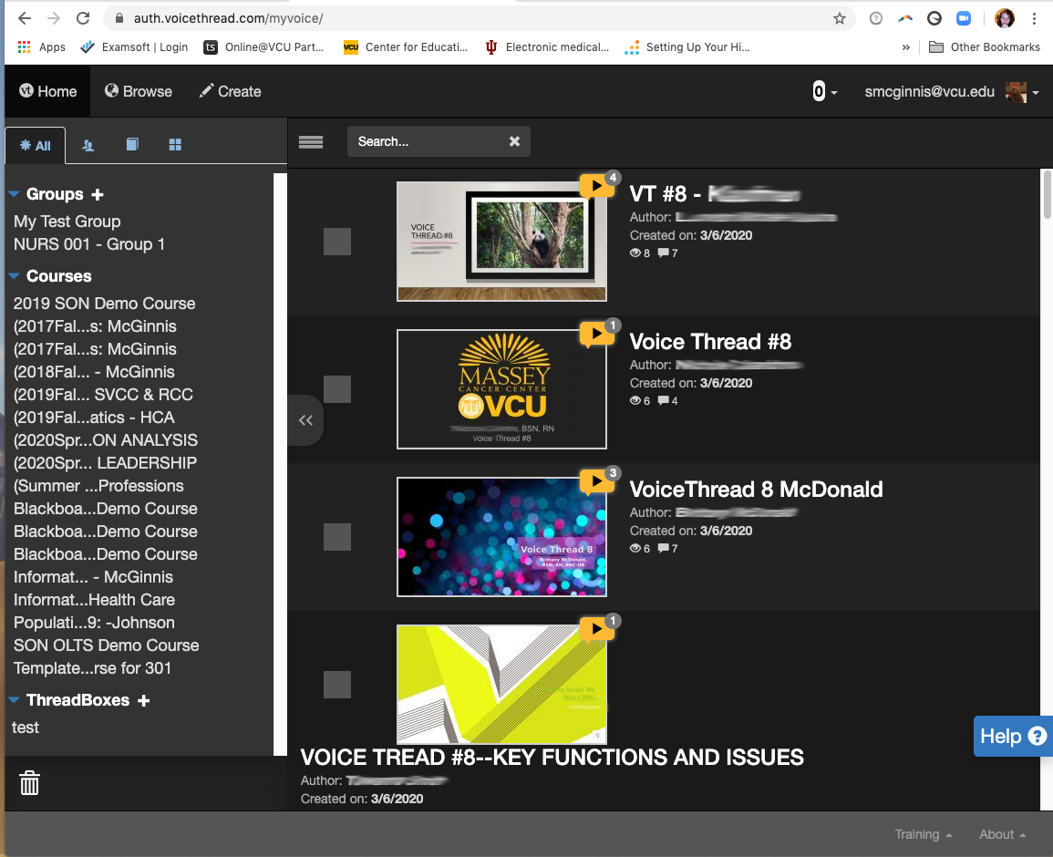
This is the VoiceThread menu.
This is a list of VoiceThreads that have been shared with you.
This is a list of your Blackboard courses using VoiceThread.

Create a New VoiceThread
To create a new VoiceThread, click the Create button at the top of the page.

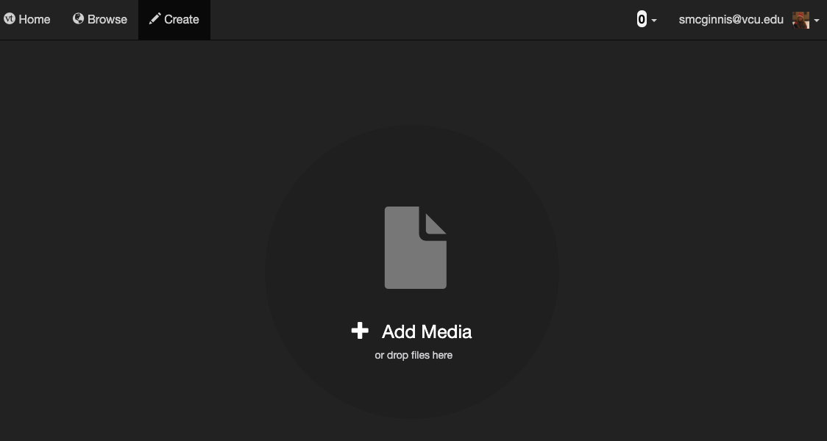

To create a voice over PowerPoint, drag and drop your PowerPoint file onto the screen and drop it on Add Media. VoiceThread will process all of your slides and make thumbnail images. While it is processing, you can give your VoiceThread a title, description and tags.
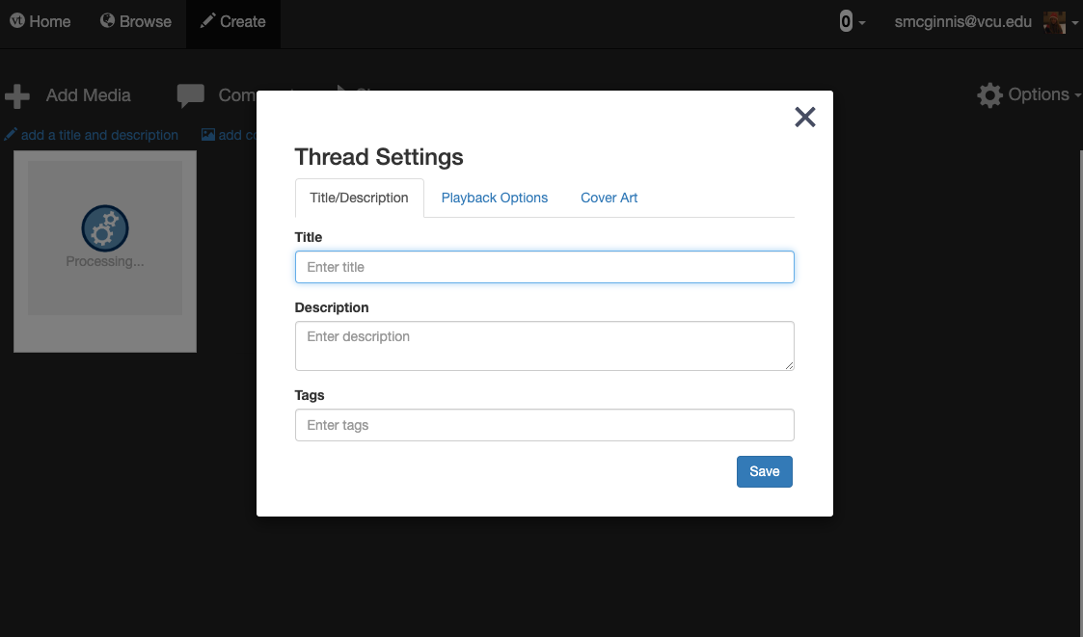

To narrate your slides, click on a slide thumbnail so that a blue rectangle surrounds the slide. Hit the comment button.

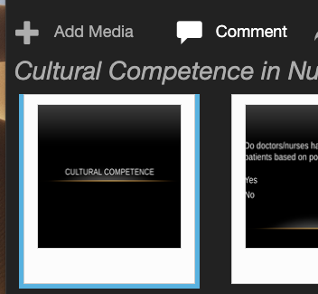

A new screen will pop up with the slide and a + sign at the bottom. Click the + sign and choose your method for commenting. 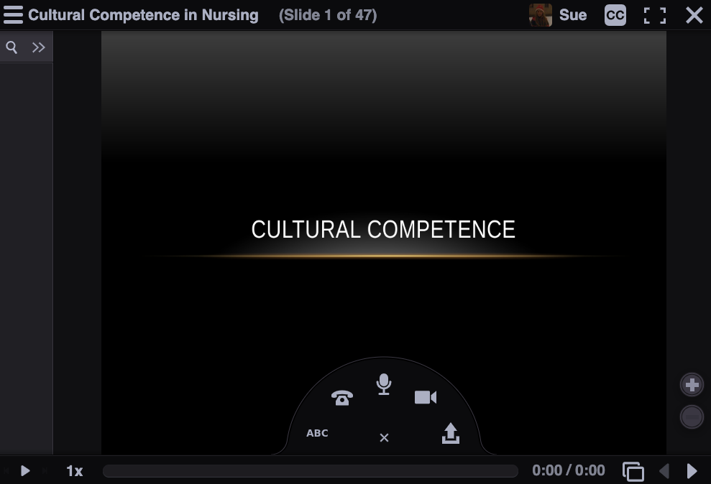

You can comment by text, phone, microphone, video, or file upload.

Choose microphone.

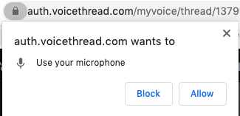
Click the Allow button to allow VoiceThread to access your computer's microphone.

A screen will countdown from 5 and then you can begin recording. You will click Stop Recording when you have finished recording. It will take you a screen that will allow you to save your recording, cancel, or record more.

If you save your comment, your VoiceThread image will appear on the left and the comment will play when you start the presentation.

Continue to advance your slides using the arrows and adding comments. If you wish to replace a slide, click the hamburger menu in the top left corner and select edit.

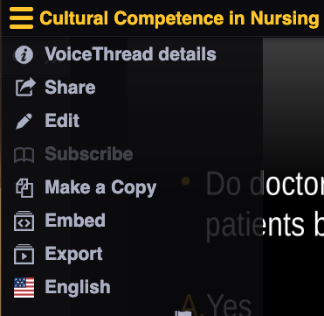

To replace a slide, click the pencil. To delete a slide, click the trashcan icon.

To have your slides advance automatically, click the options button in the upper right corner and choose Playback Settings.
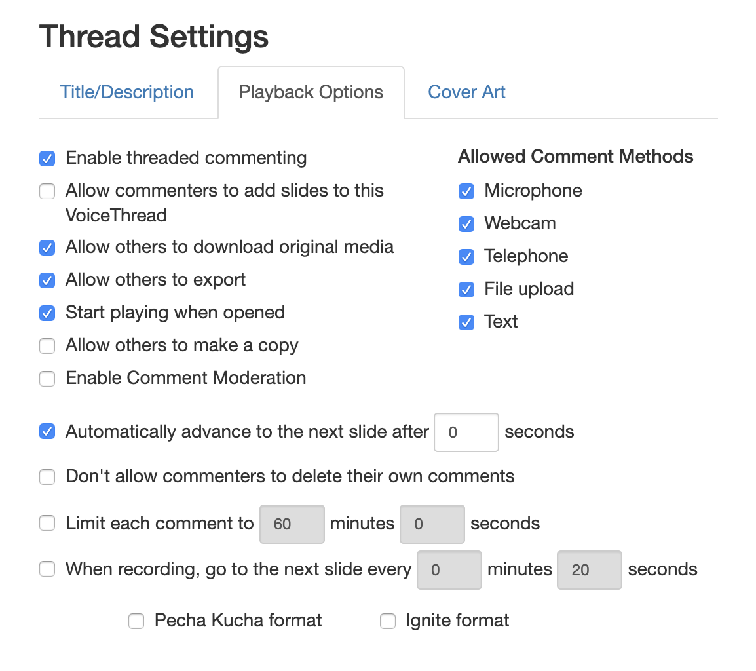
Set your slides to automatically advance to the next slide after 0 seconds if you want your VoiceThread to advance automatically when it is viewed.

When you have finished editing your VoiceThread, click Share
Press the Get a link button at the bottom.

A new window will pop up that will allow you to copy the link and determine what users can do with your VoiceThread.

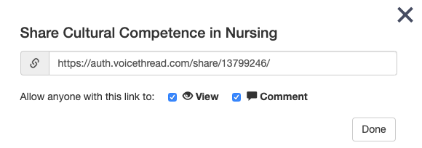
Put this link into your course for your students to enjoy.

Note: your picture will not display by default in VoiceThread, but it is a nice way to cultivate community in an online course. If you wish to add your picture to your VoiceThread profile, click your email address in the upper right corner and choose My Identities.

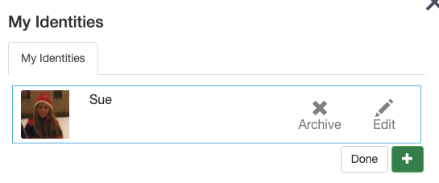
Click the Edit button to edit your name or upload your own photo.

