Create a Kaltura lecture for Blackboard
Note: This assumes IT has already installed Kaltura Capture on your computer.

Step 1: Record your lecture
- Open Kaltura Capture. The icon looks like this:

- The desktop recorder will open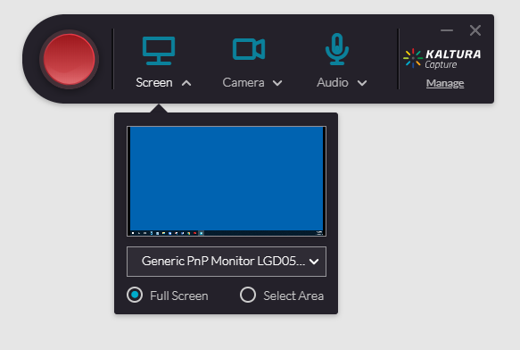
BEST PRACTICES:
- If you are using an external microphone, plug it into your computer before you launch Kaltura.
- Do not use Kaltura if your laptop is docked. It is better to only have one display

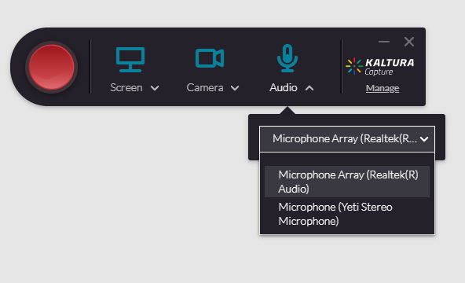
Click the Audio drop-down arrow and select the microphone you want to use to record.

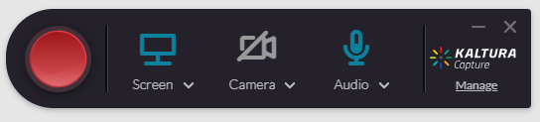
Click the Camera icon if you prefer not to include video.

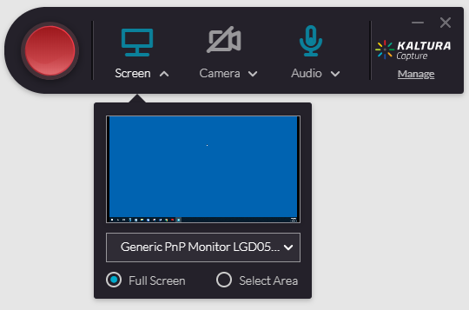
Select the area that you want to record.
Click the screen drop-down arrow. Note that you have 2 options: Record Full Screen and Select Area. Select Area is recommended because it allows you to see your slide notes and easily pause or end your Kaltura recording.

Select Area

Make sure your PowerPoint presentation is in Normal View (just as if you’re editing it).
Click the Select Area option. Your mouse will change to a cross hair. Drag to select only the slide in your PowerPoint. This will allow you to see your thumbnails, notes and the Kaltura icon as you record, but only the slide content will be captured for students.

Drag to select

Click the red record button.

You will get a 3 second countdown. Begin speaking when the countdown ends.

Pause
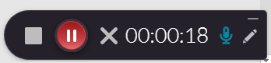
Click the Pause button at any time. Click the Stop button to end the recording.
Stop

This window will appear. Here you can do the following:
- Preview the recording
- Delete the recording
- Save the recording (this saves the recording on your computer but doesn’t give you the ability to add the recording)
- Save and upload the recording (this converts the recording to a web friendly format that you can add to your Blackboard course
- Replace the default title of the recording
- Add an optional description
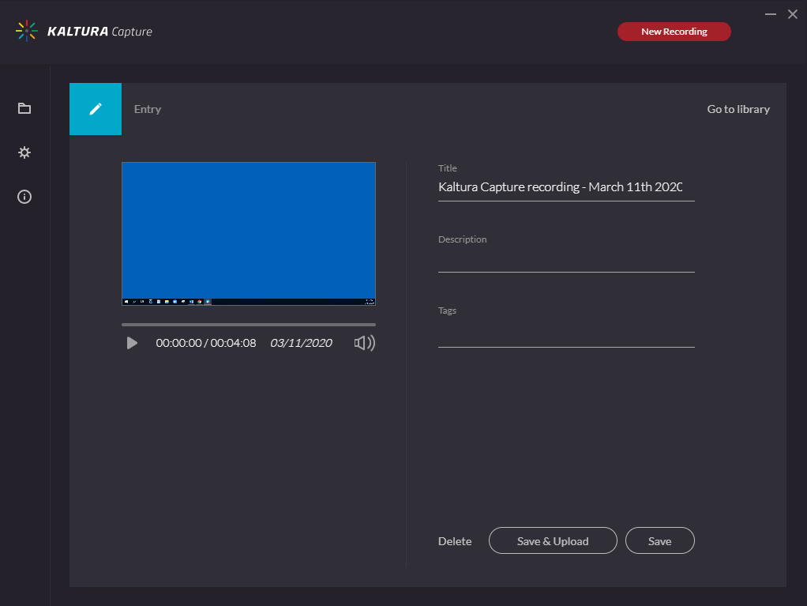
Click Save and Upload.

Click Save and Upload

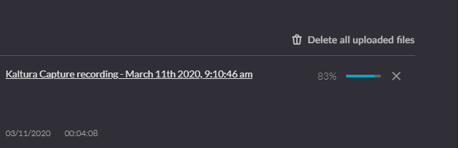
A progress meter will indicate the status of your upload. The upload file will be located in your “My Media” section of VCU Kaltura MediaSpace.

Step 2: Add your recording to Blackboard

Open Blackboard and go to the area of your course where you want students to view your video.
Click Build Content > Kaltura Media
Click the Select button associated with the video you want to add:
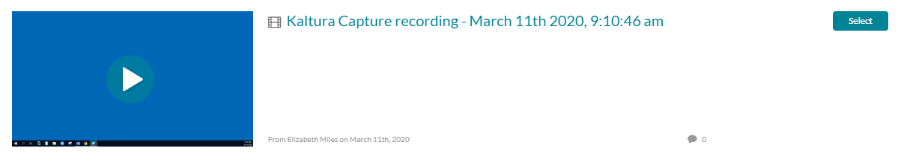
Enter a title and click Submit.

