Use Kanopy Movie Clips in a Blackboard Test

Go to VCU’s Kanopy Streaming Service , create an account, and find the film of your choice.

In order to make clips to embed in separate test questions, you will need to make some playlists. You can use the embed code for each playlist in a question or in any Blackboard item.

To make a playlist, click on your name and choose My Dashboard.

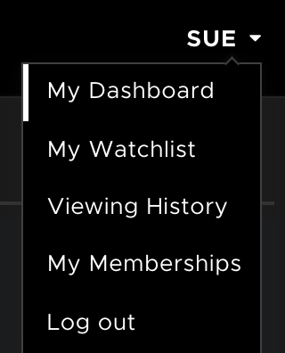

At the very top of your dashboard you will see, My Playlists. Click that link.

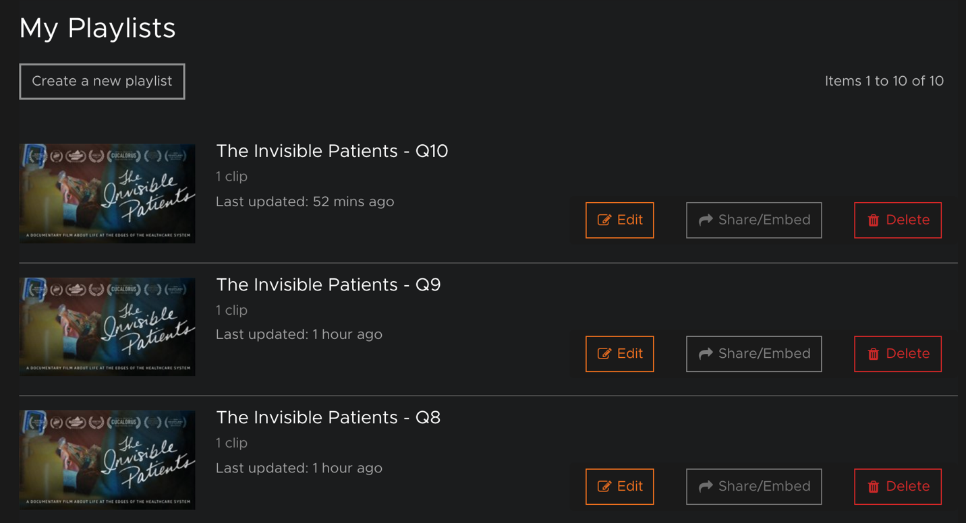
You can see from the screenshot above that each playlist has its own Share/Embed button. Since I want to take several clips from the film and use different clips in different questions, I will create a playlist for each question.

Click Create a new playlist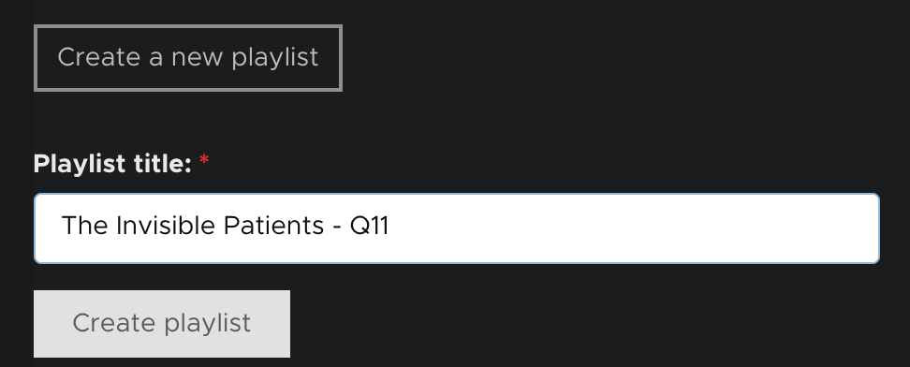

Give the playlist a meaningful name that will help you identify it later and click the Create playlist button.

You will then be brought to the next screen which allows you to add your clip.
Click the Click here to add a new clip button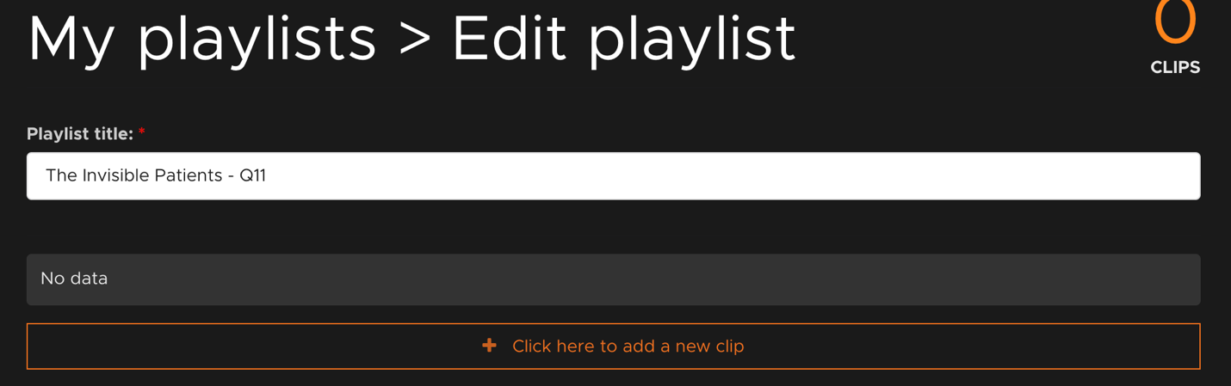

Type the name of the film and click search.

If the film is available, it will appear in your search results. Click the icon for the name of the film.
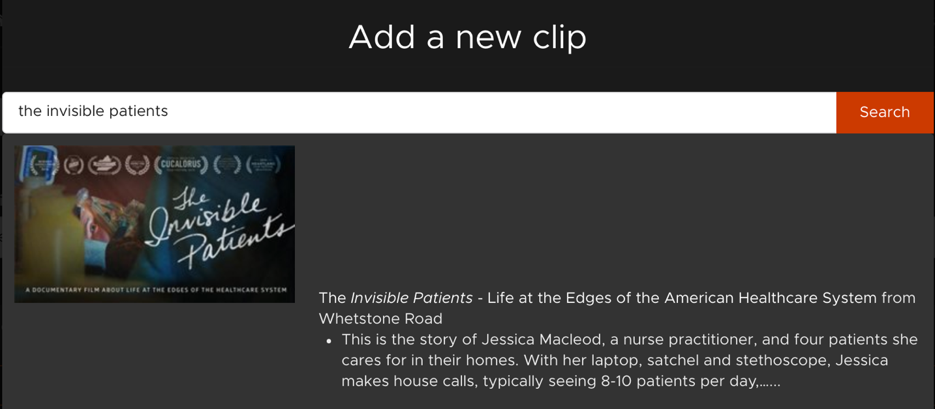

You will now have the entire movie as a clip added to your playlist. To make the clip, click the Edit button.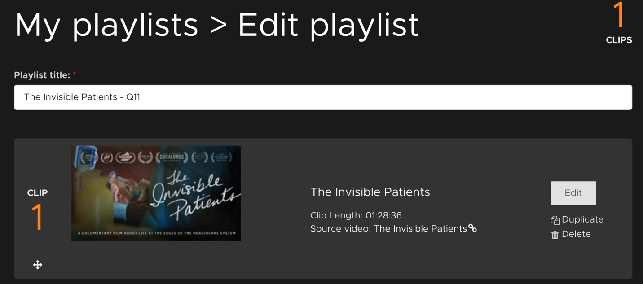

Scroll down to the bottom of the page to see the start clip time and end time. It is good to have two different tabs – one with the movie that you are playing to find the time codes and one with the edit clip screen. You can move your mouse to the movie playbar and hover your mouse over the white circle to see where you are in the film. If you get to a part that you like, hit the spacebar on your computer so that the clip pauses. Hover over the white circle to see the time code. You will use that for your beginning of the clip or the end of the clip. Put those time codes into the start time and stop time boxes.
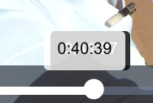
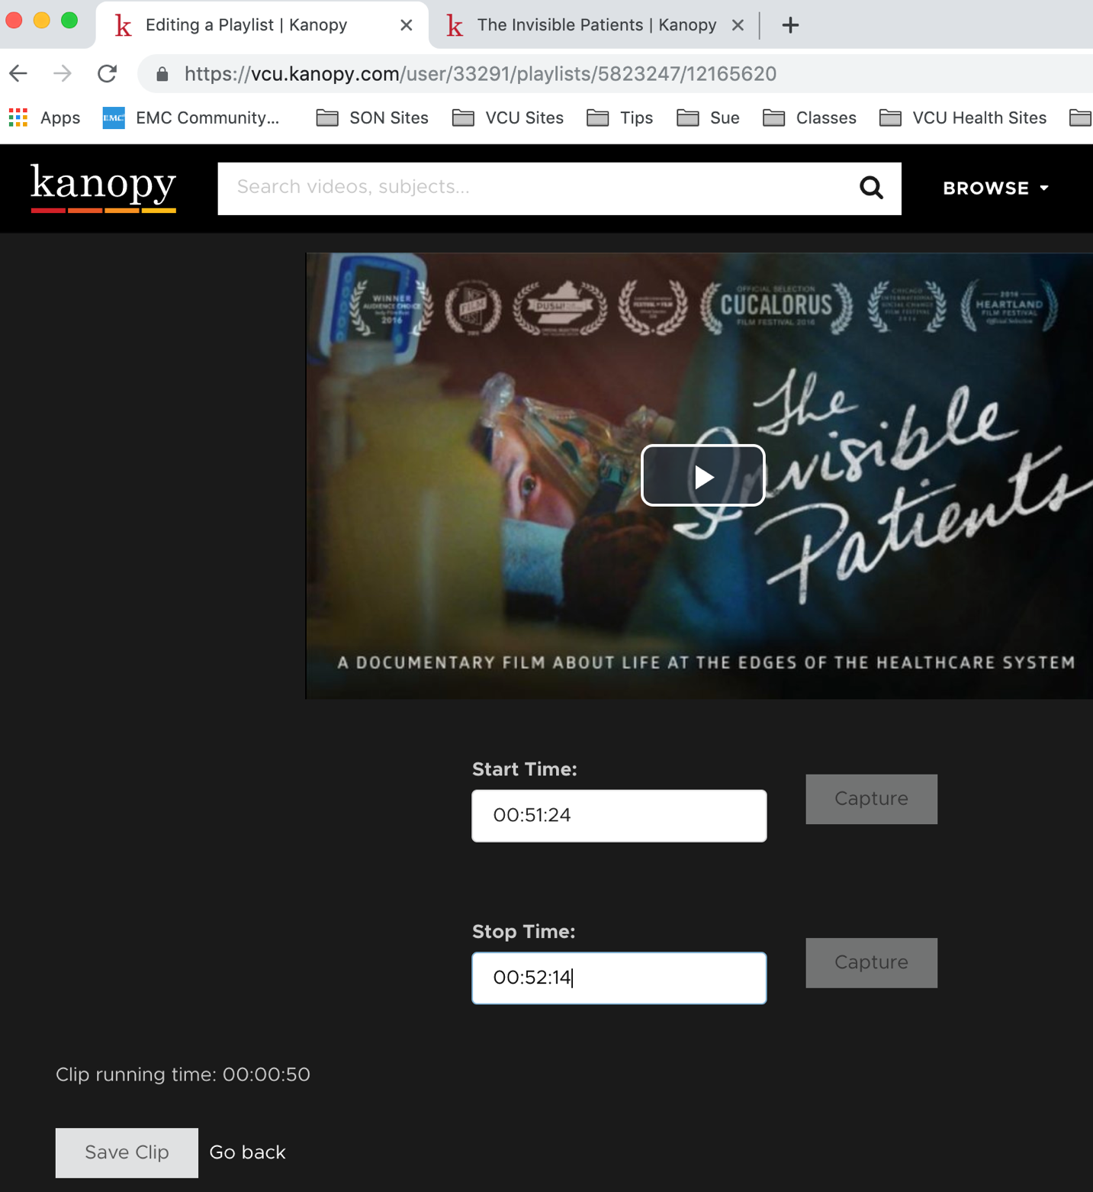

Now, go back to your Playlists by clicking the My Playlists link at the top.

Click the Share/Embed button to get the code that you will put in your Blackboard question.

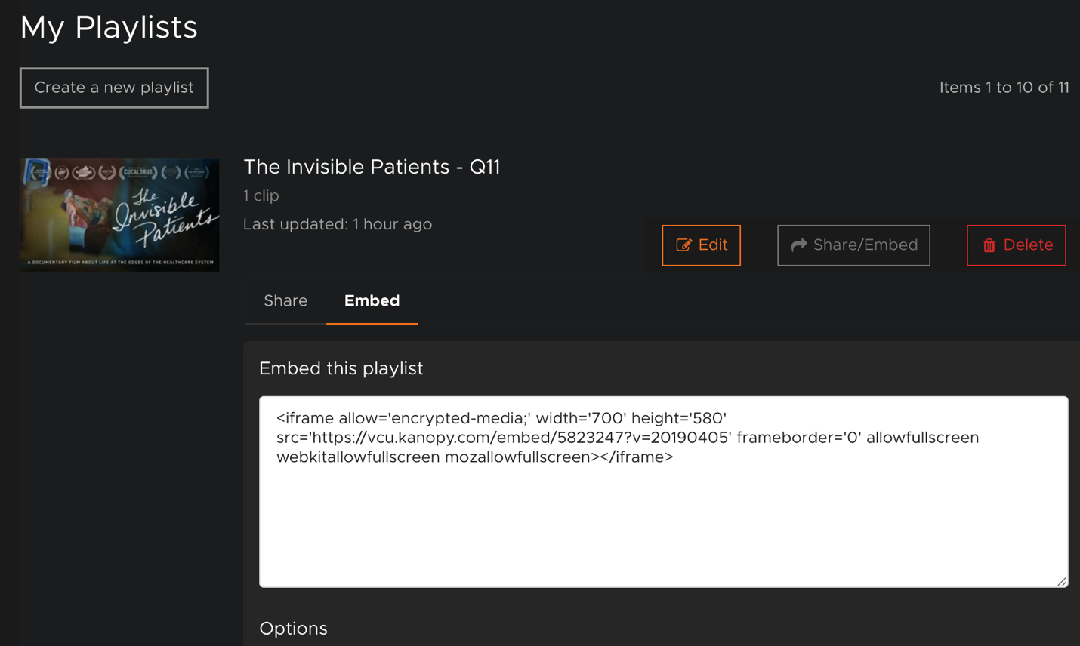

Copy the code.

Go into your Blackboard assessment and create your question and press the return button. Click the HTML button on your toolbar.

Click your cursor in between the two <p></p> tags and paste the code. It will look like this:

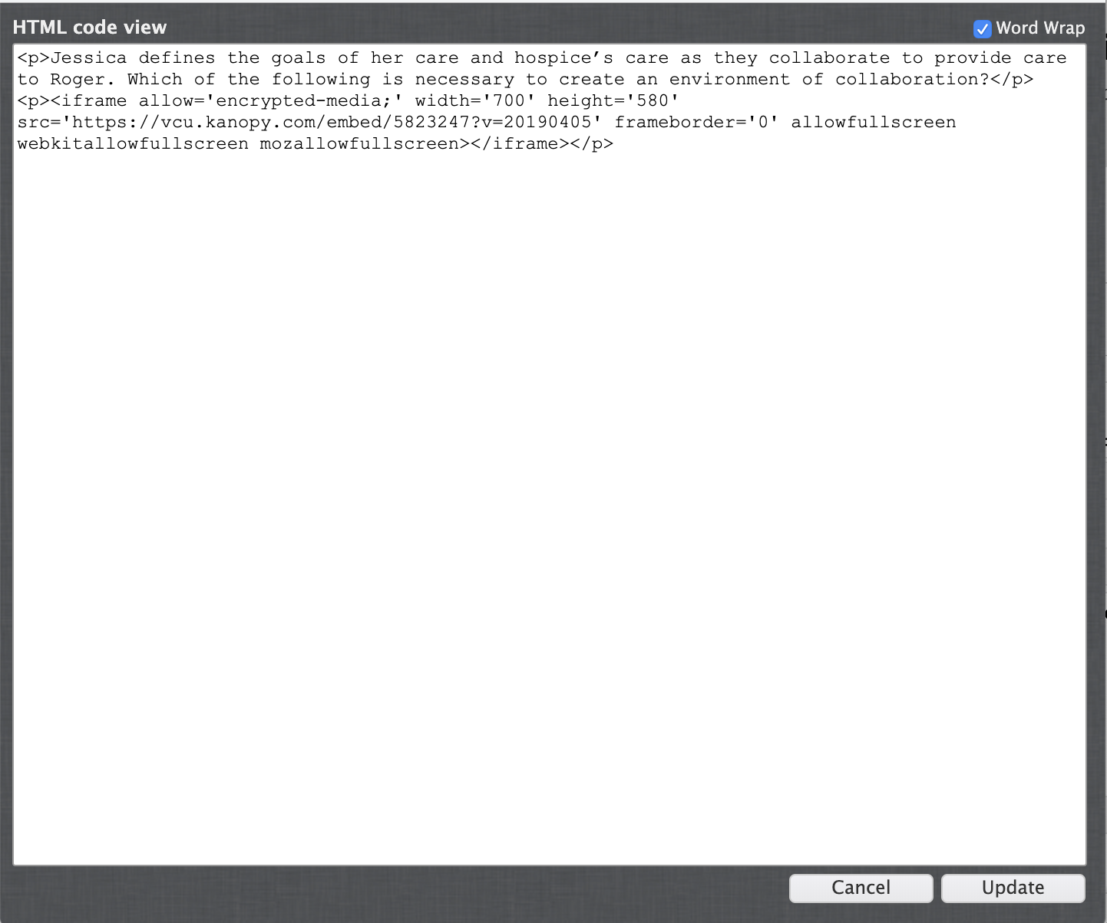

Press the submit button for the question after you have filled in your possible answers.

And your test question will look like this:
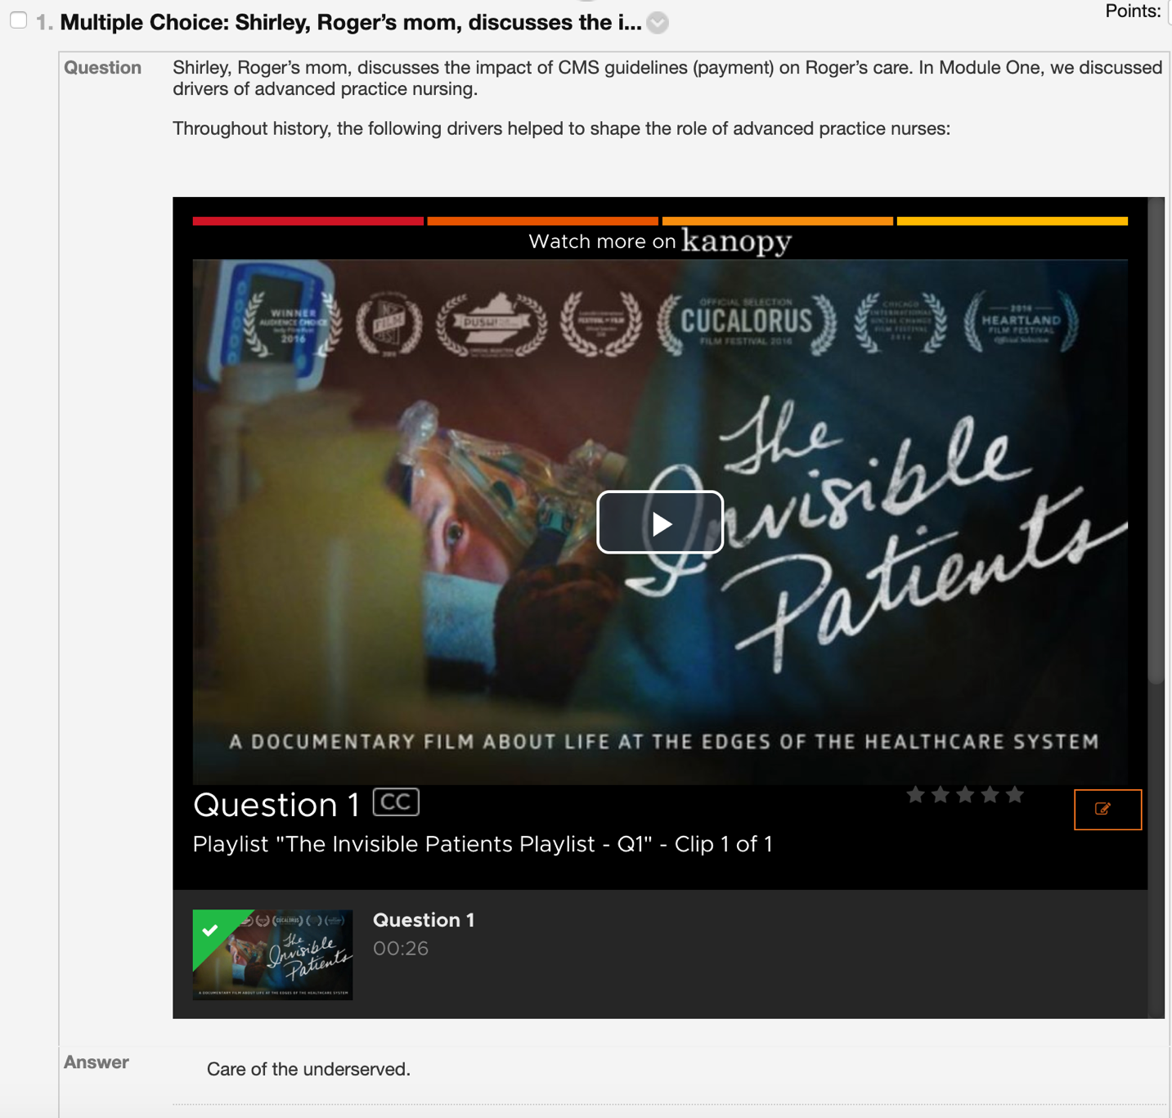

That’s it!

