Linking Echo 360 Content with a Blackboard Course

Log in to your course or organization.
Under Assessments, choose EchoCloud Captures

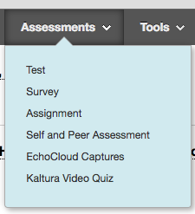

Give the information a name and click the Submit button.

Once you do, there will be a web link with that name. Click the web link. 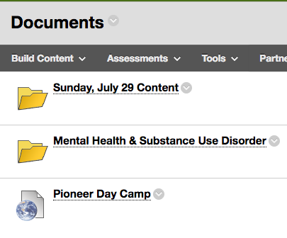
A new window will pop up and ask you to Connect your Echo360 Content. Under the Select a Section, select the EchoCloud Class you want to link. You can link to specific lectures or the list of lectures.

Choose the Section you want.

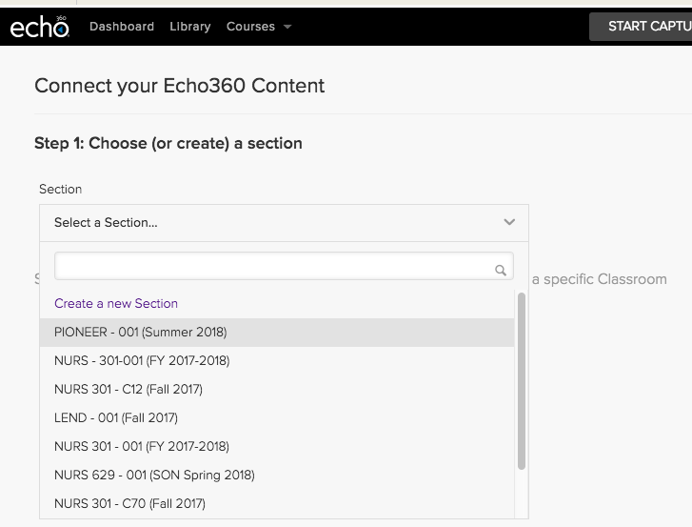

After you choose the section, you will have the option to Link to the Section Home or Link to a Classroom. A Classroom is just one video. The Section Home would be all of the videos in the course.

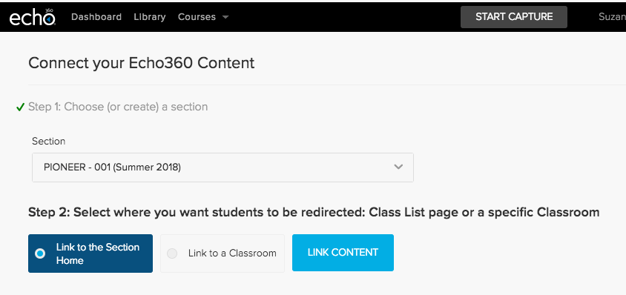

After you make your selection, choose Link Content.

All of your content will appear.
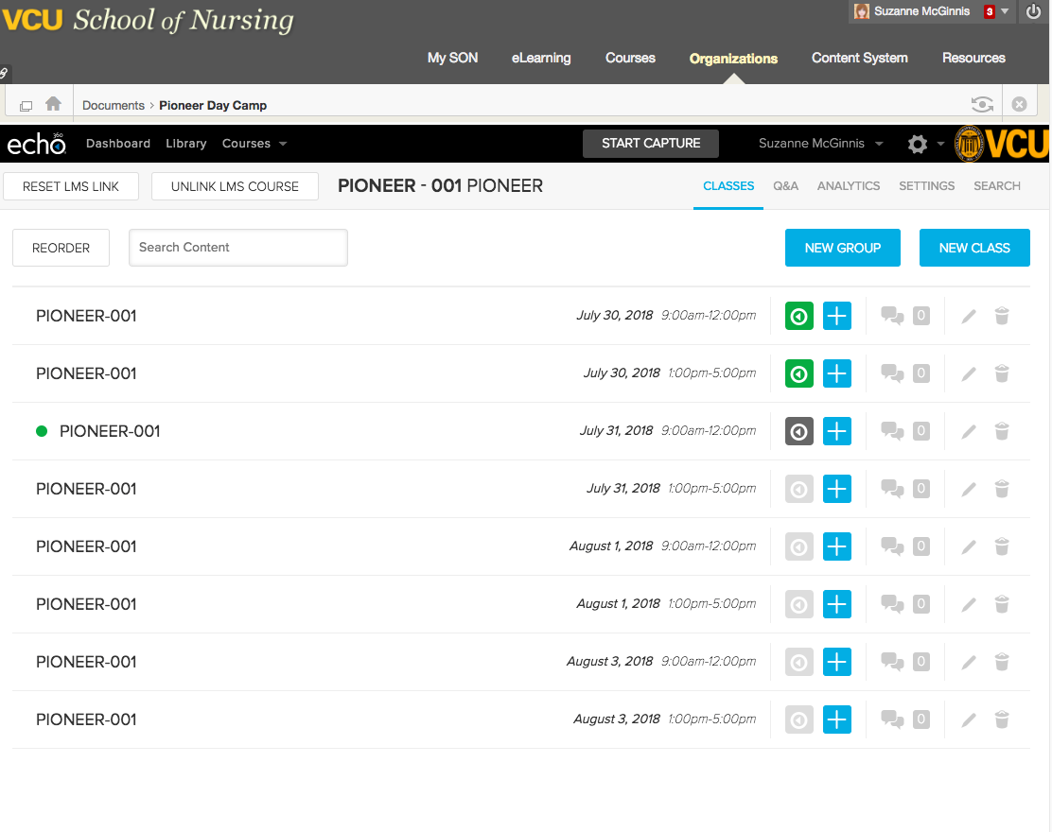
Any classes that are scheduled, but not yet processed will be greyed out. Available lectures will have a green play button.

