Using Kaltura

Log In to Kaltura
To access Kaltura at VCU, go to http://go.vcu.edu/kaltura
Click the link to log in to Kaltura.
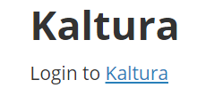
Once you arrive at the Kaltura page, look in the upper right corner and click the button that says Guest and choose Login.
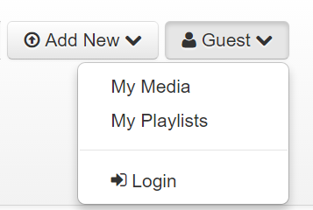
Login with your VCU eID and password.

Install the Kaltura Software
Click Add New and from the dropdown menu choose Launch CaptureSpace.
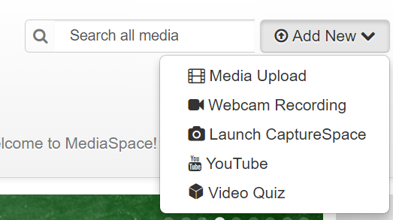
Agree to the terms and conditions presented.
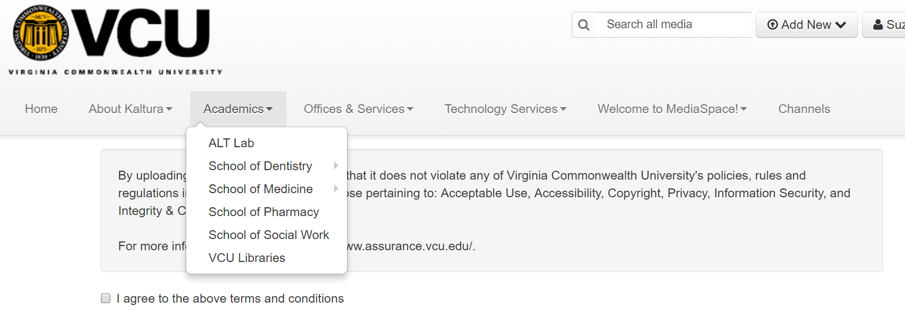
Install the CaptureSpace Desktop Recorder for Windows or Mac.
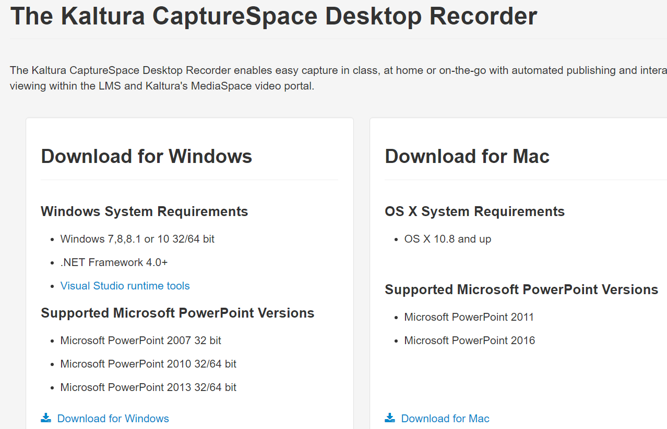
After installation, you will receive this message:
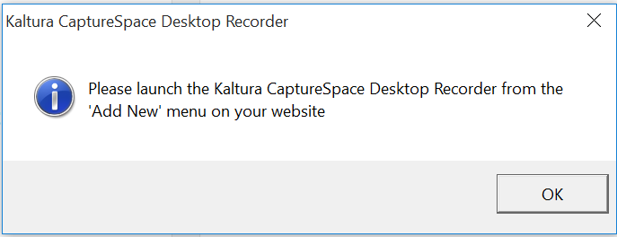
Press OK and go back up to the top of the page to press Add New and choose Launch CaptureSpace.
Agree to the terms and conditions again and you will receive this message:
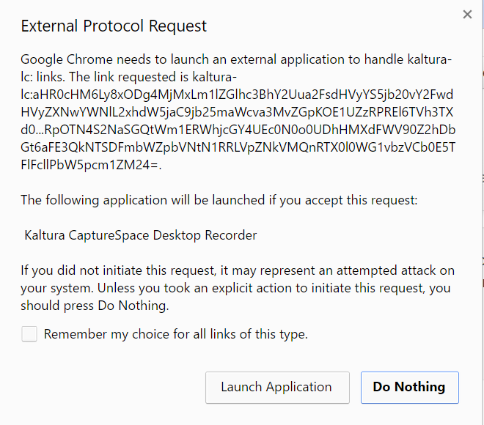
Choose Launch Application.
The desktop recorder will now launch in the lower right of your screen. 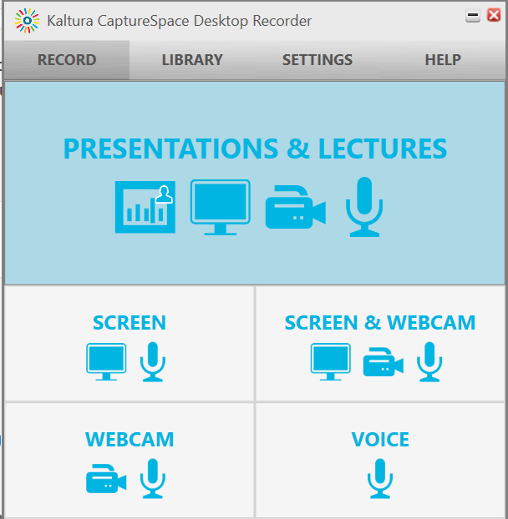

Create a Recording

You can create a webcam recording, a voice recording, screen and webcam or just screen and voice.
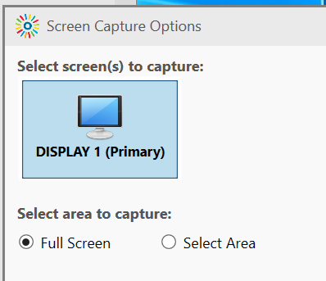
To create a voice over PowerPoint, choose screen.
Choose which area of the screen you wish to record.
(It is easiest to capture the full screen.)
After selecting the area of the screen, record your presentation.
A count down box will display that will give you 5 seconds to get your PowerPoint presentation, website, or software ready to present.
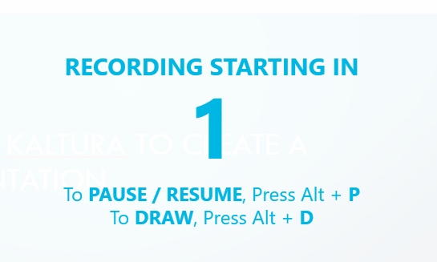
The Kaltura icon will display on your taskbar at the bottom of the screen. When you wish to pause or stop the recording, click the Kaltura icon
That will bring up your Recording Screen Capture Toolbar in the lower right of the screen.
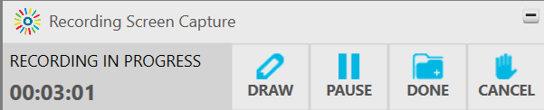
When finished with your recording, press Done.

Edit a Recording
The Kaltura editor window will appear.
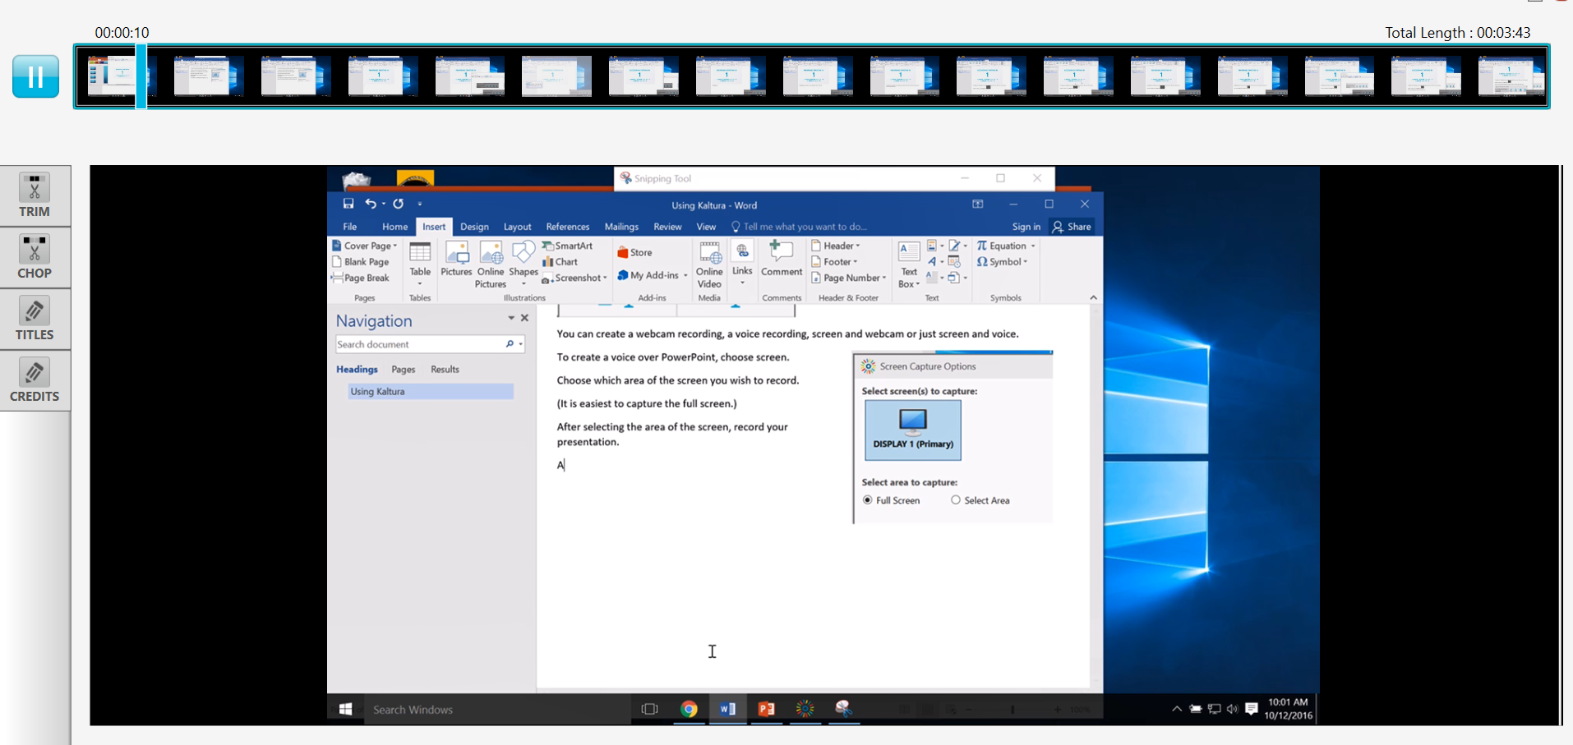
Trim your video, add titles or credits.
When finished, click Done.

Upload your Recording
Give your presentation a name and description and upload it to your My Media Space by pressing Upload.
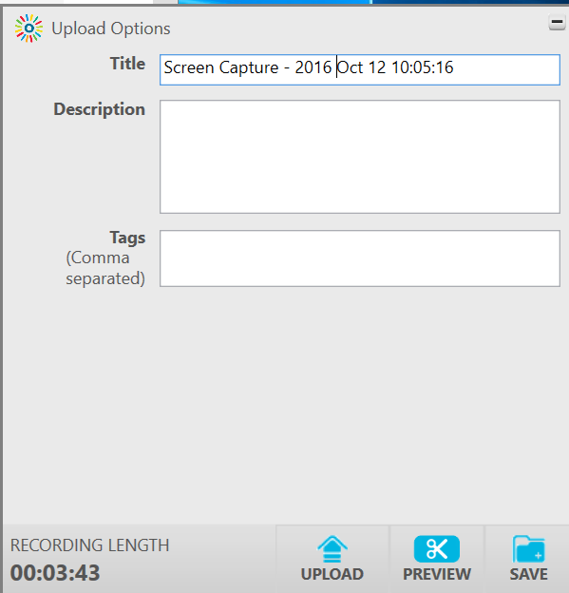
You will see a window that tells if your upload was successful.
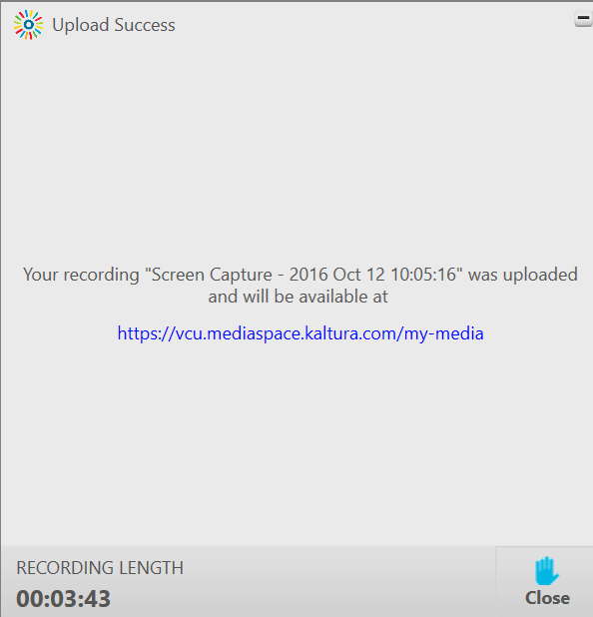

Share your Recording
There are several ways to share your recording.

Option 1: Share videos using Blackboard’s Mashup Item
Select the Build Content dropdown menu and choose Kaltura Media.
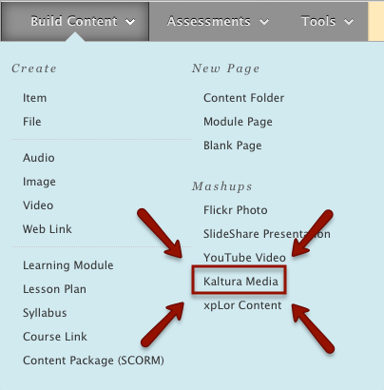
Select the video you wish to add:
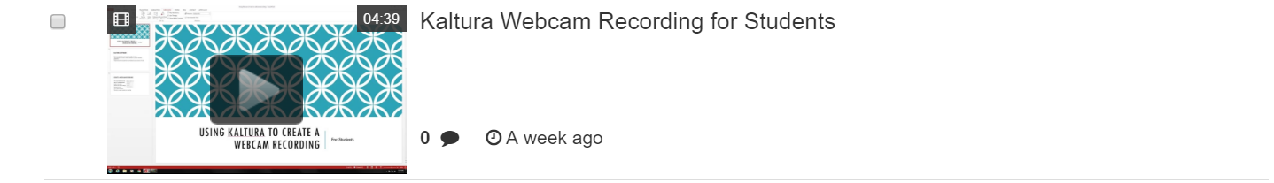
Give the mashup item a name and an optional description, then select submit.

Option 2: Sharing Kaltura videos using Blackboard’s text editor.
You can embed Kaltura videos in your Blackboard course anywhere using Blackboard’s text editor. This includes any location with a textbox: such as the discussion board or any item.
In the text editor, select Mashups > Kaltura Media
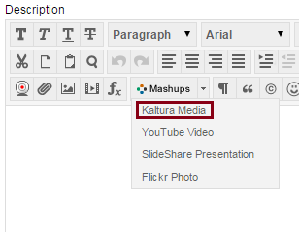
When the My Media windows opens, select an existing video from your My Media tab. Any video you’ve ever uploaded should appear.
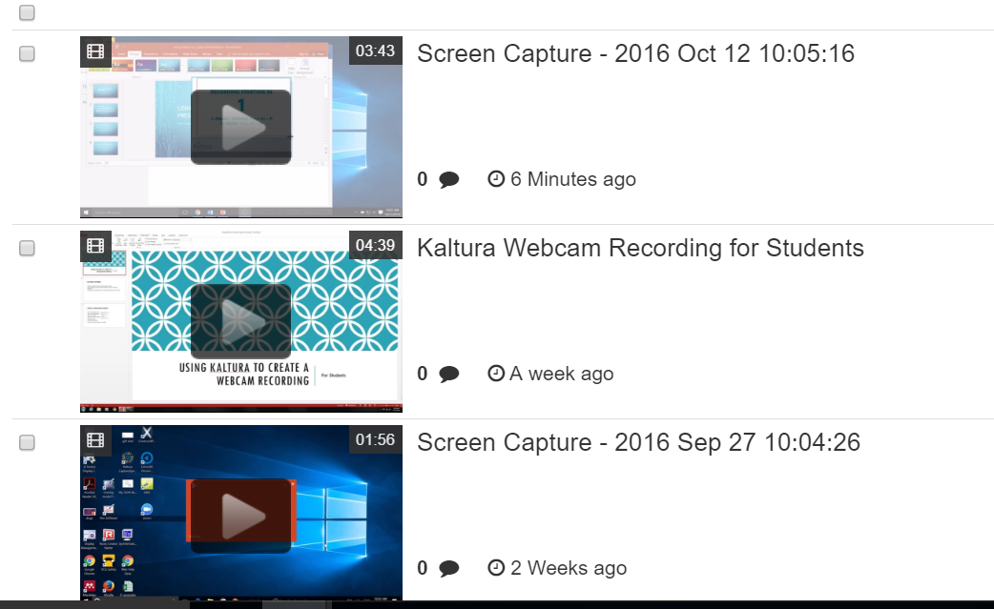
Press the Select button to embed the video back into the content editor.

Option 3: Embed them into a website via copying/pasting the video’s embed code
Go to the Kaltura site.
http://go.vcu.edu/kaltura and log in.
Click your name in the upper right corner and choose My Media
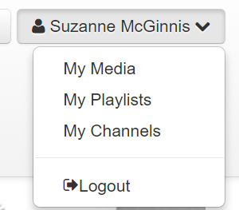
All videos that you’ve published will appear.
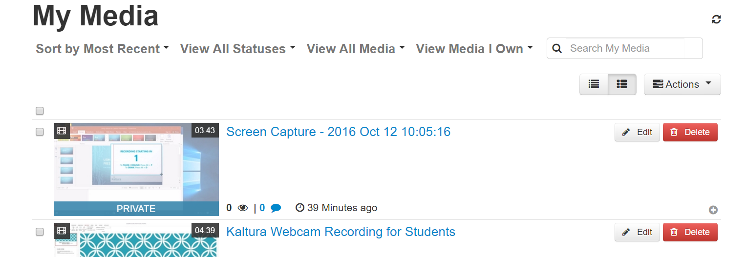
Select the video you wish to embed.
Once in the video page, click the Embed button. Copy the embed code and paste it into your blog or webpage.

Option 4: Share the video with Someone Via a Link
Go to the Kaltura site.
http://go.vcu.edu/kaltura and log in.
Click your name in the upper right corner and choose My Media
All videos that you’ve published will appear.
Select the video you wish to share via a link.
Click the Actions button and choose Publish.

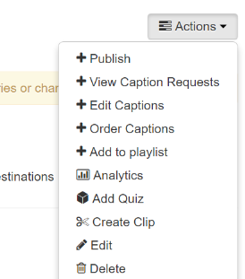
Choose Unlisted if you wish to have the media page available to anyone with a link.
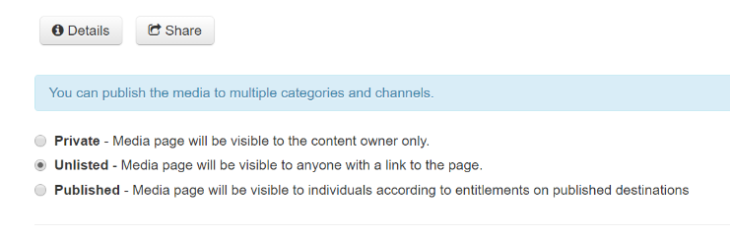
**You may be asked to add tags to your presentation so that you can find it later.
Click the Save button.
Click the Details button and copy the link. Send this link to whomever you wish to view the video.

