Using Kaltura to Create a Student Presentation

Go to the Class Discussion menu item and find the discussion for final projects.
Create a new thread for your final presentation.
Click the drop down arrow next to Mashups.
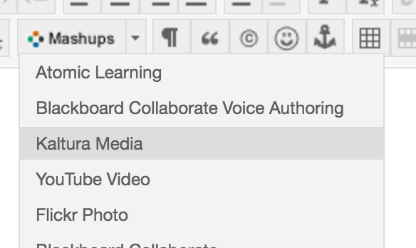

Select Kaltura Media.

In the upper right corner, next to Add New, click the drop down arrow.
Choose Launch CaptureSpace

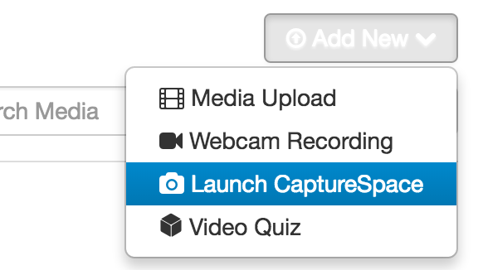

A new window will open.

Choose either Windows or Mac – depending on your operating system and install the application.

Install the program.

After installing, the program will launch and ask you to press the Add New button.

Go back to Blackboard, Discussions, Mashups and Launch CaptureSpace.

On your desktop you will see the Kaltura CaptureSpace Desktop Recorder.

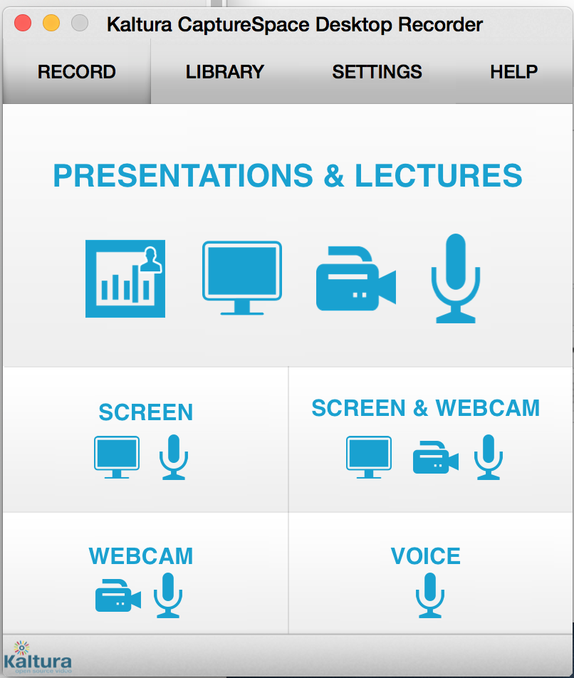

You can choose Screen or Screen & Webcam.

When you choose screen, the following window will appear:
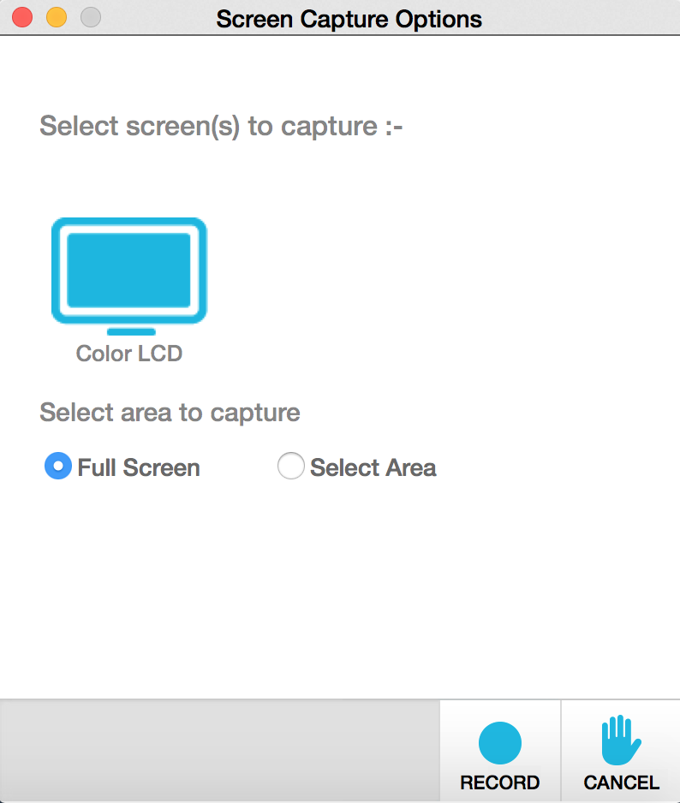

Start your PowerPoint presentation.

Press the Record button.
You will see the following screen coming up.

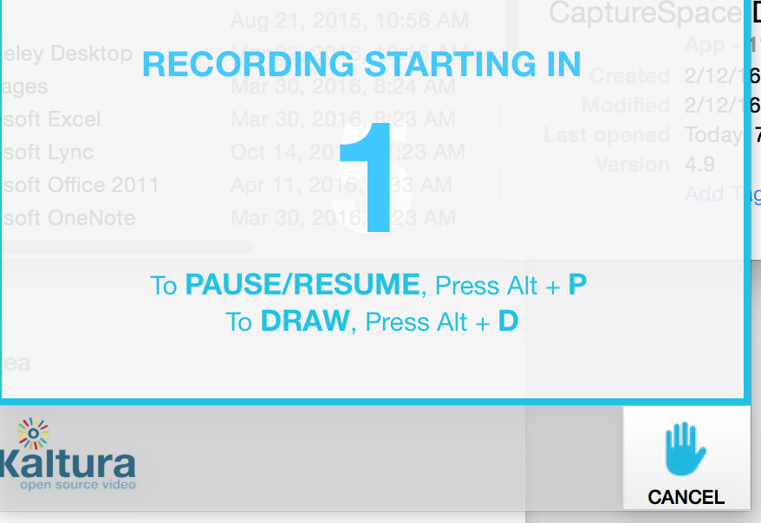

Give your presentation. When you are finished, click the colored wheel.

Click Stop Recording.

The following Kaltura bar will show:
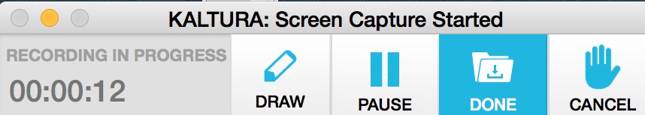

(On a Windows machine, you may need to click the wheel and choose Kaltura before seeing the above bar.)

Click Done.

The Kaltura editing window will appear.

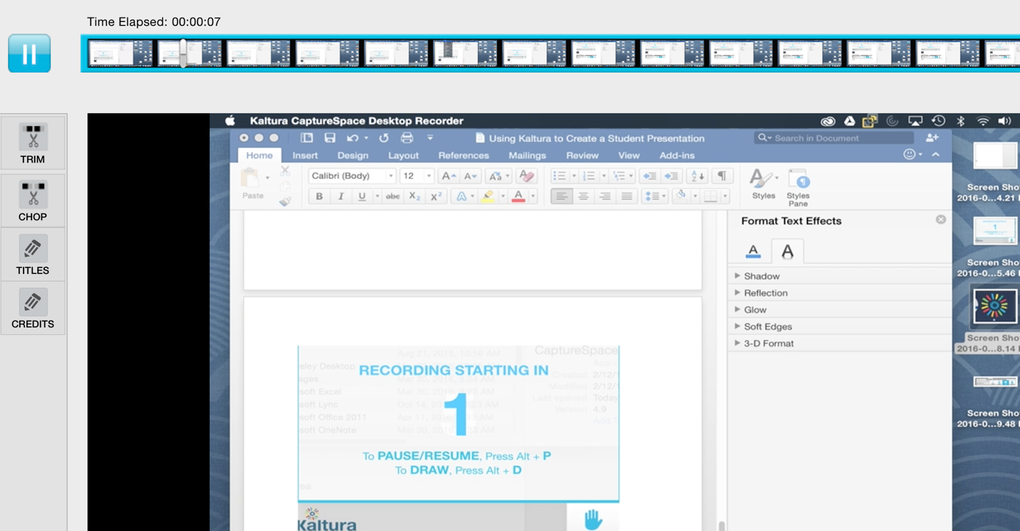

This window allows you to listen to your recording, trim the recording, add titles or even add credits.

When you are finished editing the recording, click Done in the lower right corner.

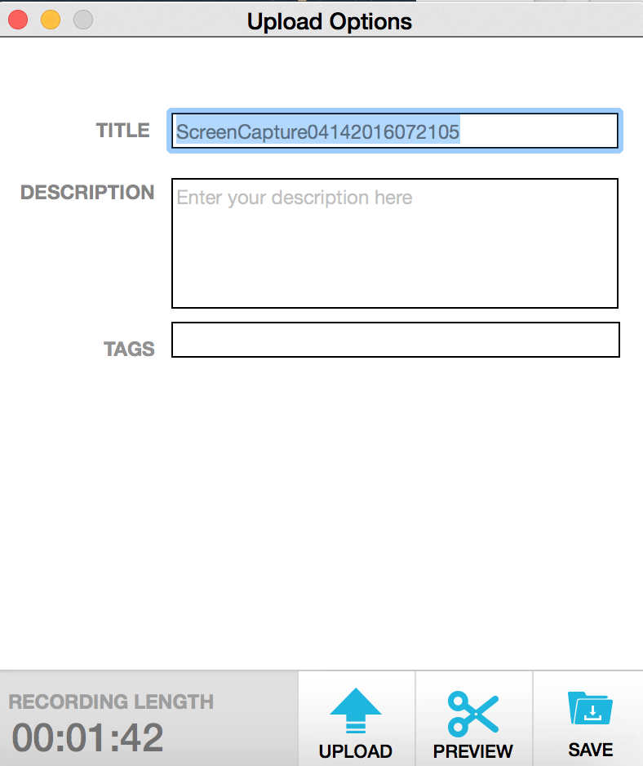

Give your recording a title and press the upload button.

You will see the following screen:
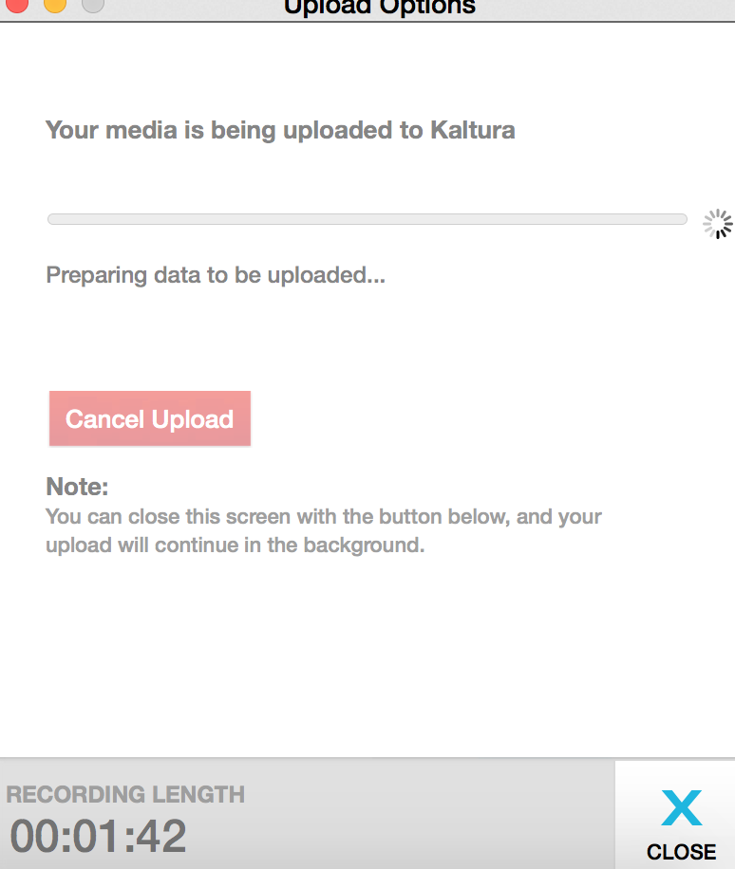

After the file uploads, the following screen will appear:
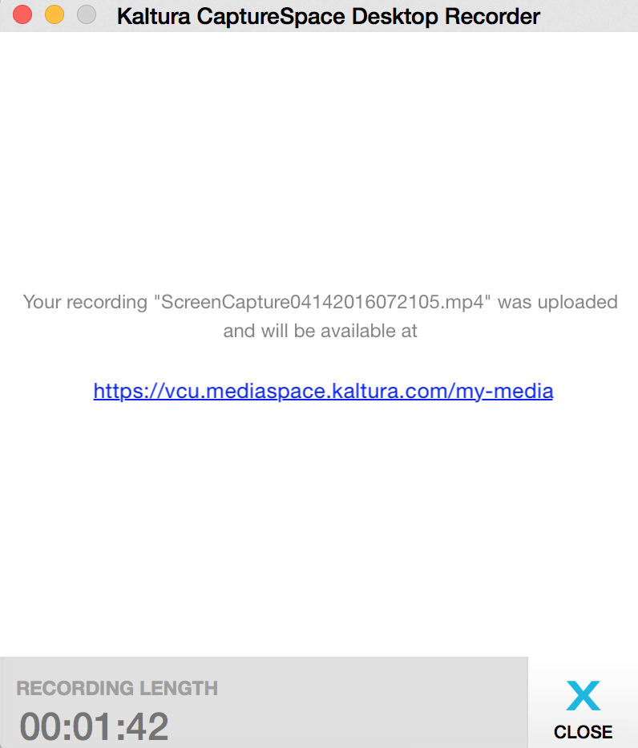

Once the file is uploaded, it is now located in your “My Media” section of VCU MediaSpace.

To add that file to Blackboard, click Kaltura Media under Mashups and press the Select button of the video you wish to add.

The video will be embedded in your discussion post.

