Creating a Blackboard Profile
You can fill out the Blackboard Profile and upload a picture that will then be available any time that you post to the discussion board or fill out a blog entry.

Please do the following:

Log in to Blackboard

In the upper right corner, click on your name

Click on the smiley face at the bottom of the first column.

When you click the smiley face, the Blackboard Social End User Terms of Service box appears. You will need to read the End User Terms of Service and agreed to the terms before proceeding.

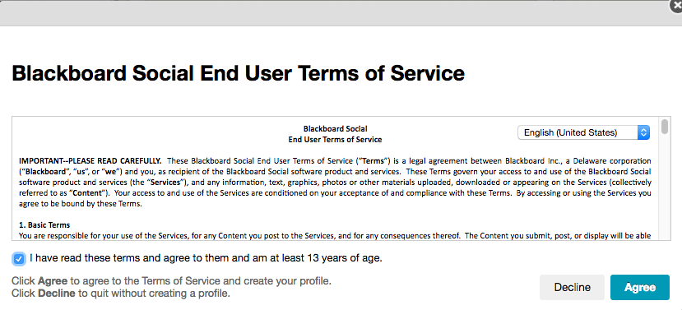
Click the Agree button.

It will next ask for your Primary Email Address. Fill in your email address and press Submit.

The next screen will ask if you have a Blackboard Profile. Click the button

Fill in the data to continue. Change I am attending to I am employed by if you are faculty. Keep it as I am attending if you are a student.

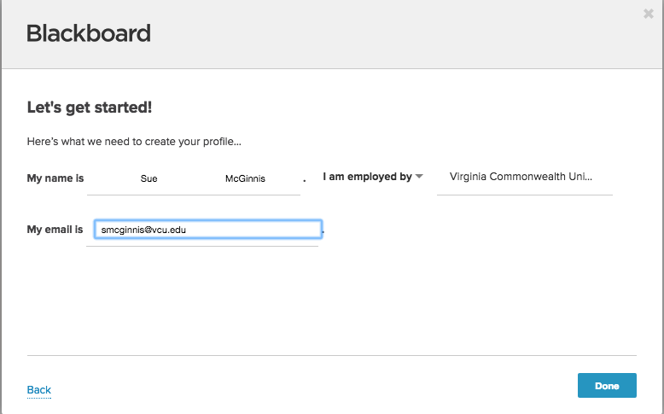

Click the Done button.

The next screen shows privacy settings. Choose to share your settings with no one or your Institution. Please choose My Institution.

Press the Done button.

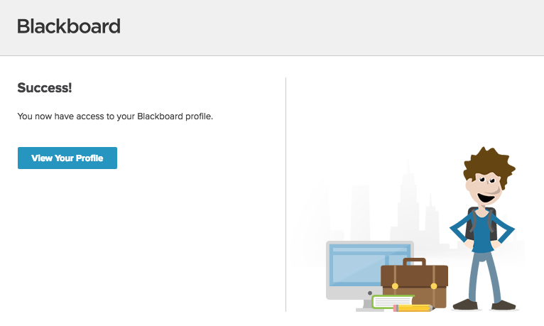

Now, you can view your profile.

Go back to your name and click the smiley face.
Then click the blank person in the upper left corner.
Click the Settings & Privacy button.
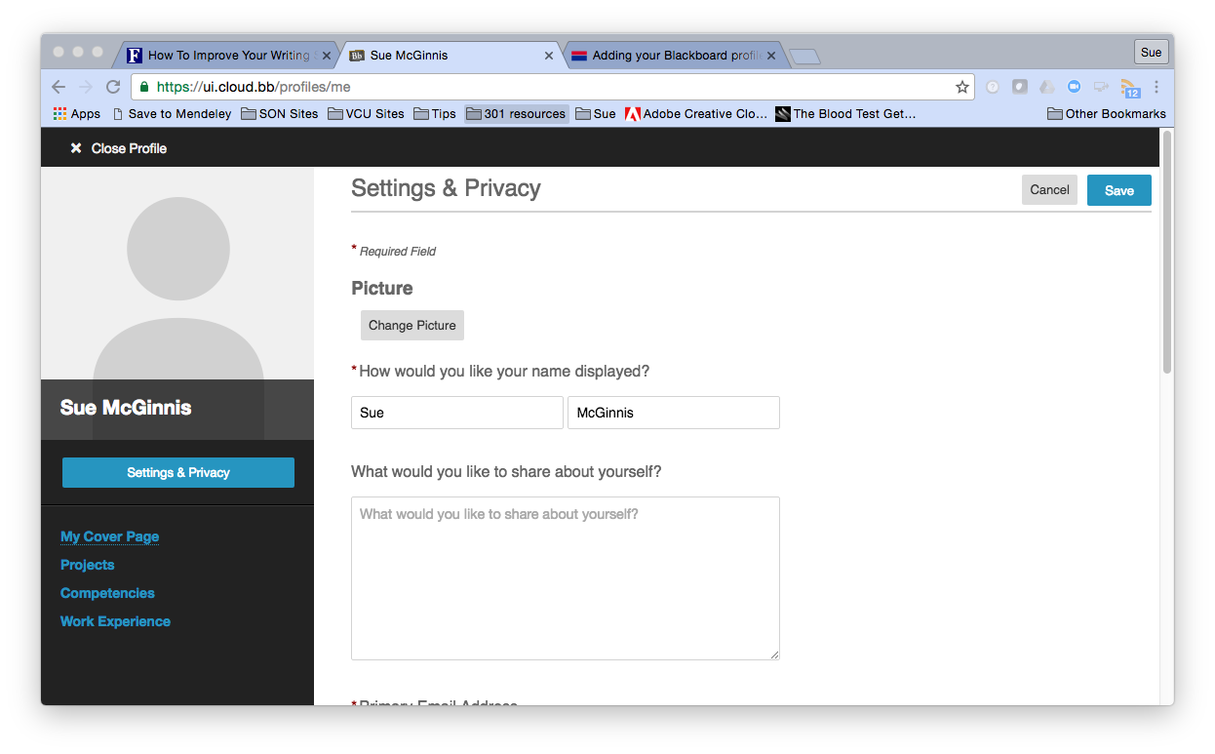

To add a picture to your profile that will appear in discussion board posts, blog entries, journals, etc. Please click the change picture button.

(NB: This is also the location where you can change how your name is displayed. My full name is Suzanne, but I often go by Sue. Changing my name here will propagate the change to all locations within Blackboard.)

Upload a picture and press the Save button.

Press the Save button again.

Now, we will see your picture when you post!

